WITHOUT PREJUDICE

File Containing Genealogical Evidence on the Family Tree of Thomas Mayo[r]*

Prepared by: Dark Emu Exposed [Website]

Date: 23 June 2023

Methodology: This genealogical report, and the alleged family tree that logically follows, has been researched and prepared by a qualified and experienced commercial genealogist(s). The alleged family tree has been constructed from the branches of each of the families that make up the tree. These are depicted as ‘through lines’ (see sections below), each of which contains links to notes and records that provide the continuity between each level of ancestor in each branch. This methodology provides the integrity to ensure that the link to the penultimate ancestor is consistent. If all branches lead back to ancestors born overseas, then this provides the evidence to suggest that none of the family’s ancestors were of Aboriginal or Torres Strait Islander (TSI) descent.

Summary: This file contains genealogical records and evidence used to construct the alleged family tree of Thomas Mayo[r] author, Uluru Statement from the Heart campaigner and Referendum Working Group member. These research records should be read in conjunction with the accompanying summary diagram, Thomas Mayo[r]’s Alleged Family Tree.

These records rely on the claims by Thomas Mayo[r] himself, given in an interview, that his father is Celestino Mayor and his mother is Liz Mayor (Source).

Based on this genealogical research, it appears that Thomas Mayo[r]’s ancestors are predominately, on his father’s side, from Malaysia, the Philippines, Nuie, Vanuatu, Singapore and Germany.

Although many were born in the Torres Strait Islands (TSI), we have not been able to locate any records that confirm that any are actually of TSI indigenous ancestry. It is possible that, of Thomas Mayo[r]’s sixteen 3X great-grandparents on his father’s side, four may be Indigenous Torres Strait Islander’s or Aboriginal, but we could find no official records to support any claimed ‘Indigeneity’. Records could be found to support the claim that Thomas Mayo[r]’s other twelve 3X-great-grandparents were born overseas and are thus ‘non-Indigenous’.

Based on Thomas Mayo[r]’s own claims, his mother Liz Mayor is only of ‘Polish, Jewish and English ancestry’ and is non-indigenous.

Disclaimer: This genealogical work has been undertaken in good faith and is based on the publicly available records. However, it cannot account for events which may result in Aboriginal or Torres Strait Islander (TSI) ancestry entering into the family line, such as via a private or unrecorded adoption of an Aboriginal TSI or child into the family, or a relationship out of wedlock between a family member and an Aboriginal person that produced a child of Aboriginal or TSI descent who was then incorporated into the family without record, or with a record that did not disclose the Aboriginality or TSI-descent of that child.
* Thomas Mayo himself decided in Nov 2022 to change his name from Mayor back to Mayo as per his claimed grandmother’s married name
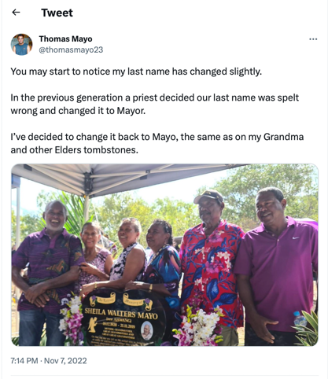
(Source Twitter).
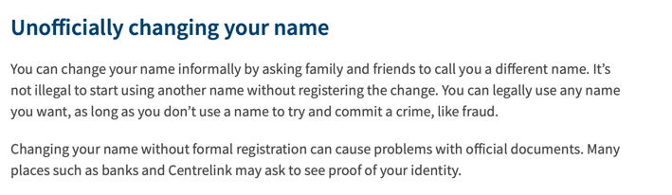

Source

MAYO/MAYOR Family Through Lines – Red Text Indicates possible Aboriginal or TSI Ancestry

Adriano Mayor  Philippine Islands |  | m. - |  | Antonia Nigalang  Philippine Islands
Felix Mayor  b. c. 1877 Infanta Zambales, Philippine Islands – d. 25 January 1930 Thursday Island  See Notes 4 |  | m. 5 August 1907  Thursday Island |  | Johanna Pavian  b. c. 1887 Horn Island – d. unknown  See Pavian/Fabian Family
Anthony (Tony) Mayor  b. 1922 Thursday Island – d. 1970 Thursday Island  See Notes 3 |  | m. - |  | Sheila Walters Ahwang  b. 19 December 1928 – d. 21 November 2019  See Ahwang Family
Celestino (Ceddy) Mayor  b. c. 1954 Thursday Island  [Purported Father of Thomas Mayo(r)]  See Notes 2 |  | m. ? |  | Elizabeth (Liz)
Thomas Mayor  See Notes 1 |  | m. ?

PAVIAN/FABIAN Family Through Lines– Red Text Indicates possible Aboriginal or TSI Ancestry

Vicento Molan  Philippines |  | m. ? |  | Patrona Gregorio  Philippines
Gregorio Leon Fabian/Pavian  b. c. 1855 Colebra, Philippine Islands – d. 8 October 1901 (Queensland)  See Notes 6 |  | m. 28 June 1888  Thursday Island |  | Philomena Kadoba  b. c.1864 Mabuiag Island – d. before or in 1906?  [Father: Woosarkie; Mother: Toemacap]  Possibly Indigenous TSI  See Notes 6
Johanna Pavian  b. c. 1887 Horn Island – d. unknown  See Notes 5 |  | m. 5 August 1907  Thursday Island |  | Felix Mayor  b. c. 1877 Infanta Zambales, Philippine Islands – d. 25 January 1930 Thursday Island

AHWANG Family Through Lines – Red Text Indicates possible Aboriginal or TSI Ancestry

La Mat  Malaysia |  | m. - |  | La Hant  Malaysia
Jaffa Ahwang  b. c. 1862 Singapore, Straits Settlement – d. 18 July 1937 Thursday Island  See Notes 9 |  | m. 3 June 1891  Thursday Island |  | Annie Savage  b. c. 1873 Badu Island TSI – d. 3 December 1956 Darnley Island  See Savage Family
Saptu Ahwang  b. c. 13 September 1895 Badu Island – d. 8 October 1976 Thursday Island  See Notes 8 |  | m. 26 July 1920  Thursday Island |  | Leila Walters Motlop  b. 16 July 1905 – d. 2 December 1944 Thursday Island  See Motlop / Motolava Family
Sheila Walters Ahwang  b. 19 December 1928 – d. 21 November 2019  See Notes 7 |  | m. ? |  | Anthony Mayor  b. 1922 Thursday Island – d. 1970 Thursday Island

SAVAGE Family Through Lines – Red Text Indicates possible Aboriginal or TSI Ancestry

Maivanga (Joe) Savage  b. c. 1858 Niue Island (Pacific Islands) – d. 23 June 1922 (Queensland)  See Notes 11 |  | m. - |  | Zarazar (Sarah) Monahou  b. c. 1858 Badu Island – d. 16 June 1923 (Queensland)  [Father: Mano; Mother: Kodagud]  Possibly Indigenous TSI  See Notes 11
Annie Savage  b. c. 1873 Badu Island – d. 3 December 1956 Darnley Island  See Notes 10 |  | m. 3 June 1891  Thursday Island |  | Jaffa Ahwang  b. c. 1862 Singapore, Straits Settlement – d. 18 July 1937 Thursday Island

MOTLOP / MOTOLAVA Family Through Lines

Dowar Motolava  Moto Lava, Vanuatu |  | m. - |  | Sarah  Moto Lava, Vanuatu
Thomas Motlop / Motolava  b. c. 1869 Moto Lava, Vanuatu – d. 25 November 1914 (Queensland)  See Notes 13 |  | m. 12 September 1896  Thursday Island |  | Polly Noelke  b. c. 1876 on a Schooner in the Torres Straits – d. 30 December 1937 Thursday Island  See Noelke Family
Leila Walters Motlop  b. 16 July 1905 – d. 2 December 1944 Cairns Queensland  See Notes 12 |  | m. 26 July 1920  Thursday Island |  | Saptu Ahwang  b. c. 13 September 1895 Badu Island – d. 8 October 1976 Thursday Island

NOELKE Family Through Lines – Red Text Indicates possible Aboriginal or TSI Ancestry

William Noelke  b. c. 1848 Perleberg, Germany – d. 24 January 1939 (Queensland)  See Notes 15 |  | m. - |  | ‘Warelipug’  Unknown  [Possibly Indigenous TSI or Aboriginal? – No records found to confirm Indigeneity]
Polly Noelke  b. c. 1876 on a Schooner in the Torres Straits – d. 30 December 1937 Thursday Island  See Notes 14 |  | m. 12 September 1896  Thursday Island |  | Thomas Motlop / Motolava  b. c. 1869 Moto Lava, Vanuatu – d. 25 November 1914 (Queensland)

Notes 1: Thomas MAYOR
Source : InFocus - Thomas Mayor
….
Mayor, who lives in Darwin, is also a son, brother and father. He is the eldest of three children, and one of his two sisters is a teacher. His father, Celestino Mayor, is a Torres Strait Islander of Philippine and Dayak ancestry and his mother, Liz Mayor, brings Polish, Jewish and English ancestry to the family…..
It was Mayor’s father who connected him to culture, however indirectly. Celestino Mayor was born under the Aboriginals Preservation and Protection Act 1939 (Qld), and was among the first generation to escape the total control of the supposed “Protector” when this Act was repealed by the Aboriginal and Torres Strait Islander Affairs Act 1965….
“His attitude was to just work hard, not complain, and get on with it,” Mayor says. “But we practised culture in our own ways. Dad taught me to hunt traditional foods, such as turtles and dugongs. I was also fortunate enough to practise and perform island dancing as I was growing up, with other Torres Strait Islanders in the Darwin community who did express culture.”….

Notes 2: Celestino (Ceddy) MAYOR / MAYO
1959 School Sports Torres News, 23 June 1959, p. 9
Sports Day….
Boys 5…..Celestino Mayo
1961 Communion Torres News, 14 November 1961, p. 9
First Communion
The happy first communicants were….
Celestino Mayo
1963 Art Award Torres News, 6 August 1963, p. 11
Prize Winners….
Pencil Drawing. Trees…..Celestino Mayo
1966 Art Award Torres News, 2 August 1966, p. 13
Q.C.W.A. Art Show…..
Special prize to…. & Celestino Mayo
1967 Art Award Torres News, 25 July 1967, p. 15
Winners of Children’s Art Competition….
Section 3. 11-13 years…
Second. Celestino Mayor
1968 Art Award Torres News, 24 October 1967, p. 13
State Primary School……
Entries were forwarded from this school to the Palm Island Show held recently. Several pupils from this school were successful in gaining prizes they were Celestino Mayo. 1st. Drawing.
Photo 2015
Memorandum, March 2015 – Edition 31 p.15
Memorandum is a quarterly publication of McArthur River Mining
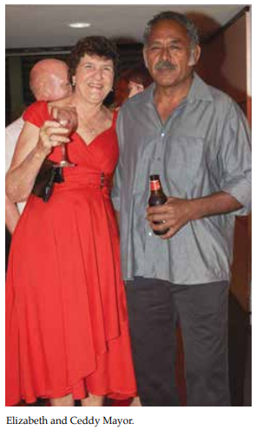

Notes 3: Anthony (Tony) MAYOR / MAYO
1922 Birth QLDBDM# 1922/C/6355
Anthony Mayor
Birth Date: 15 April 1922
Father: Felix Mayor
Mother: Johanna Fabian
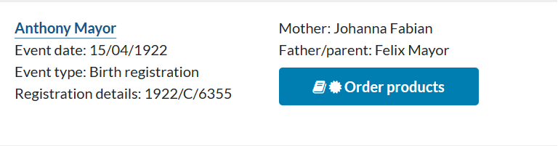
C1950 Marriage No Marriage record found
1954 Residence Australia, Electoral Rolls, 1903-1980
Mayor, Anthony, Hargreave st., Thursday Island, seaman
[Brother] Mayor, Celestino Michael, Thursday Island, labourer
Mayor, Shiela Warters [Walters], Hargreave st., Thursday Island, home duties
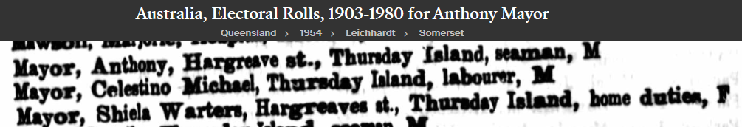
1957 Hospitalised Torres News, 30 April 1957, p. 10
Ambulance Activities….
On Easter Monday Mr. Anthony Mayo had to be brought back from a crayfishing expedition, after being . ..stung by a sting ray. He was transported to the local hospital by the Ambulance.
1958 Residence Australia, Electoral Rolls, 1903-1980
Mayor, Anthony, Hargreave st., Thursday Island, seaman
Mayor, Shiela Warters [Walters], Hargreave st., Thursday Island, home duties
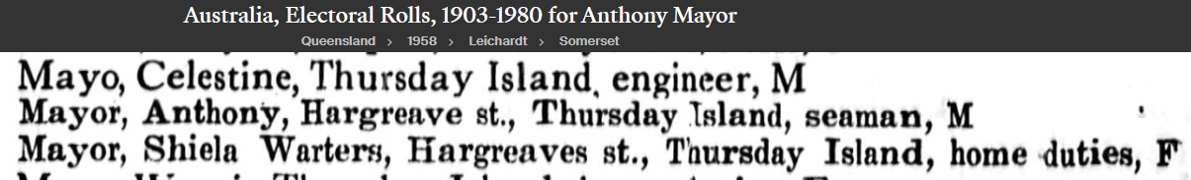

1963 Residence Australia, Electoral Rolls, 1903-1980
Mayor, Anthony, Hargreave st., Thursday Island, seaman
Mayor, Shiela Warters [Walters], Hargreave st., Thursday Island, home duties
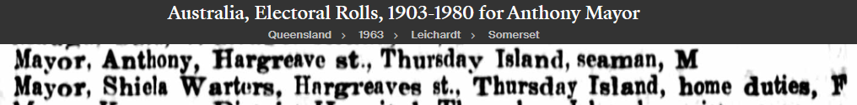
1968 Residence Australia, Electoral Rolls, 1903-1980
Mayor, Anthony, Hargreave st., Thursday Island, seaman
Mayor, Shiela Warters [Walters], Hargreave st., Thursday Island, home duties
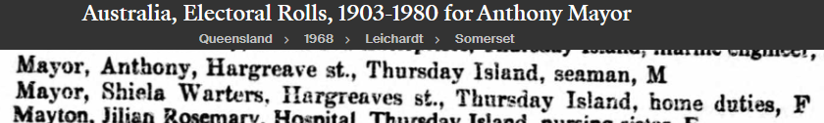
1970 Hospital Torres News, 5 May 1970, p. 11
Friends of Mr. Tony Mayor were shocked to hear of his sudden collapse last Monday afternoon. Tony is at present in the local hospital in a serious condition.
1970 Death QLDBDM# 1970/C/3409
Anthony Mayor
Date of Death: 6 May 1970
Father: Felix Mayor
Mother: Johanna Paruan
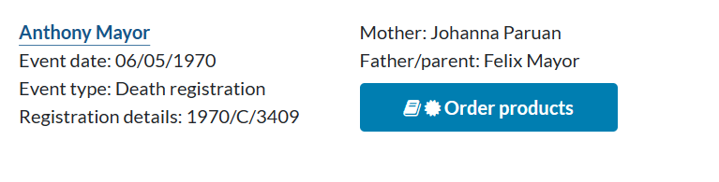
1970 Death Torres News, 12 May 1970, p. 12
DEATH OF LOCAL RESIDENT
After his sudden collapse on Monday 5th. May, Mr. Anthony Mayor aged 48 years passed away quietly, without regaining consciousness on Wednesday 13th.
Tony who was an employee of the Hospitals board for many years was born and educated on T.I. he married a local girl, Sheila Ahwang and they have spent all their married life on the island. Tony was an extremely popular member of the community, he leaves a family of six to mourn their loss. Deepest sympathy is extended to his wife and family.

1970 Thanks Torres News, 12 May 1970, p. 10
THANKS
Mrs Sheila Mayor and family wish to thank sincerely all relatives and kind friends who sent messages of sympathy and floral tributes during her recent sad bereavement Special thanks to the Doctors, Matron , Sisters, Nursing, Kitchen and general staff of the local hospital also Rev .Fathers McSweeny and Flynn and the Sister's of Mercy for their kindness to her husband during his last illness
1970 Death Feast Torres News, 26 May 1970, p. 7
The death feast for the late Tony Mayor was held at the home of Mr.& Mrs Victor Nona last Saturday.
1971 In Memoriam Torres News, 4 May 1971, p. 7
MAYOR. Anthony, In loving memory of my deer husband and our dear father Anthony Mayor who passed away on May 6th 1970…..
1971 Feast Torres News, 7 December 1971, p.18
Mrs S. Mayor and family request the pleasure of those who sent cards and floral tributes of sympathy and those who attended the funeral of the late Mr Tony Mayor and Mr. Tino Mayor
to their Tombstone Feast at the Catholic Hall on the 11th December.
Time 4 30p.m.
1971 Feast Torres News, 14 December 1971, p.3
Over 200 guests were entertained at a special feast at the Catholic Hall last Saturday evening when Mrs Shiela [sic] Mayor, her family and relatives marked the occasion of the blessing of the tombstone of her late husband, Mr Anthony Mayor and her brother Mr Celestino (Tino) Mayor.
1972 In Memoriam Torres News, 9 May 1972, p. 4
MAYO, Anthony…..In loving memory of my dear husband, our dear father Anthony Mayo who passed away on 6th May, 1970.
1977 In Memoriam Torres News, 10 May 1977, p. 11
MAYOR - Anthony. In memory of our loving father, father-in-law, Grandfather who passed away on 6th. May, 1970.
" A Heart of gold stopped beating , His smiling eyes at rest,
God broke our hearts to prove to us, He only takes the best".
Remembered by his children Handle, Tommy, Ceddy, Fabienne, Kathy and Willie.

Notes 4: Felix MAYOR / MAYO
1907 Marriage QLDBDM# 1907/C/2657
Date of Marriage: 5 August 1907
Place of Marriage: Thursday Island

Felix Mayor, Bachelor
Place of Birth: Infanta Zambales, Philippine Islands
Occupation: Sailor
Age: 30
Father: Adriano Mayor, Farmer
Mother: Antonia Nigalang

Johanna Pavian, Widow
Place of Birth: Thursday Island, Somerset, Queensland
Age: 20
Father: Leon Pavian, Sailor
Mother: Philomela Kadola
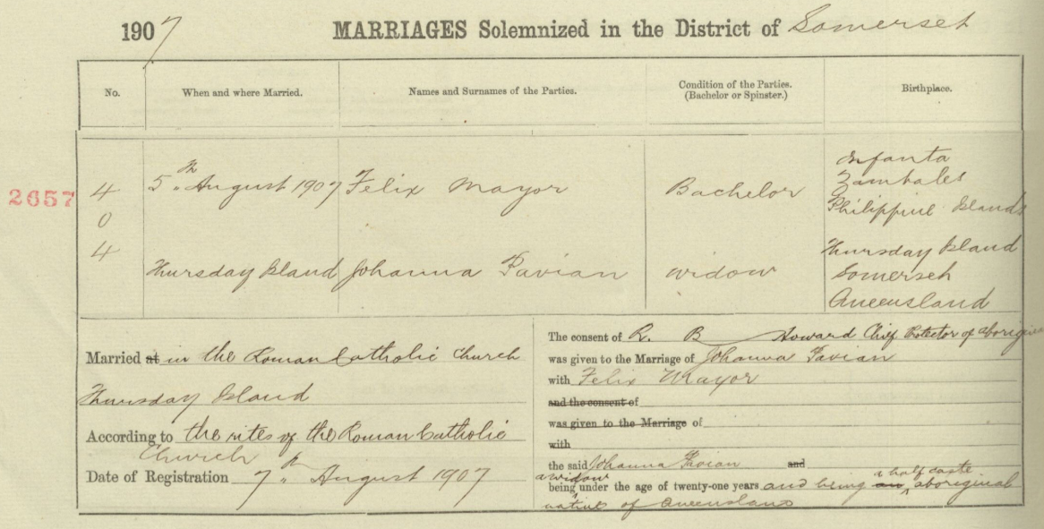
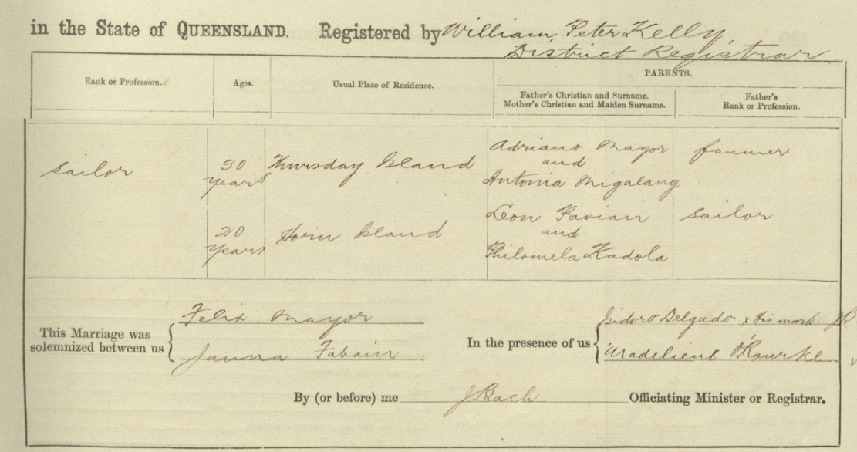
1930 Death QLDBDM# 1930/C/836
Felix Mayor
Date of Death: 25 January 1930
Father: Adriano
Mother: Antonia Nigalang
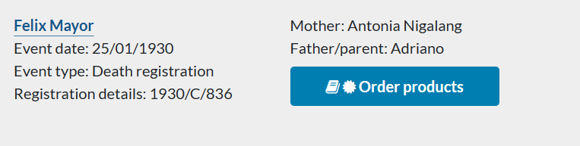

Notes: Birth of Daughter – Agnes on Horn Island
Source: Navigating Boundaries
Chapter 4: They don’t know what went on underneath
Three little-known Filipino/Malay communities of Torres Strait
by Anna Shnukal
Table 4.2: Horn Island births 1889–1932 – p. 94
9 September 1908 Birth of Daughter – Agnes
Table records:
Felix Mayor – Place of Birth: Philippines
Johanna Fabian – Place of Birth: Thursday Island

Son: Thomas Adrian Mayor/Mayo [‘Voice advocate’ Thomas Mayo’s great uncle – his father’s uncle]
Australian Military Forces – World War II
Thomas Adrian Mayo
Service No.: D404
Date of Birth: 13 December 1913
Place of Birth: Thursday Island
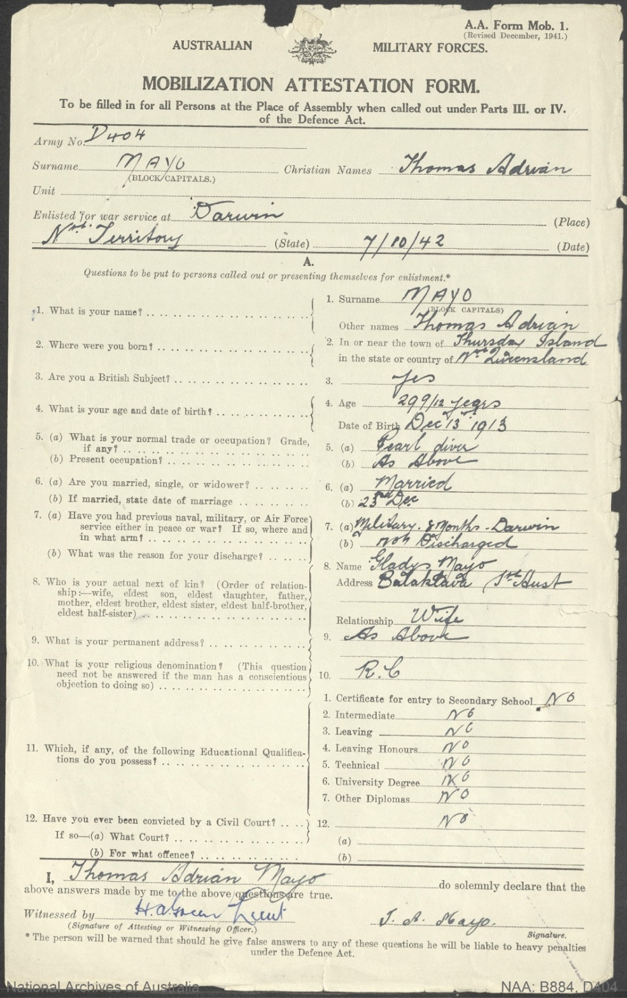

Australian War Memorial
Filipino boy, Private Tom Mayo
Painting by Arthur Murch, 1942, Darwin, Northern Territory
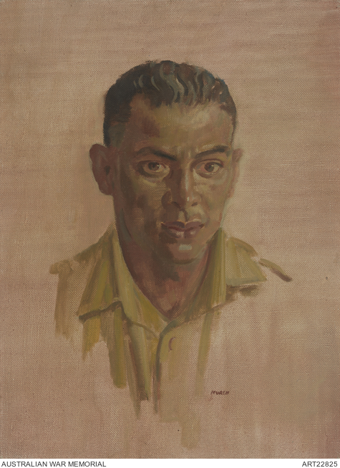

Son: Celestino Mayor. [‘Voice advocate’ Thomas Mayo’s great uncle – his father’s uncle]
Born: 6 April 1920
Father: Felix Mayor
Mother: Johanna Fabian
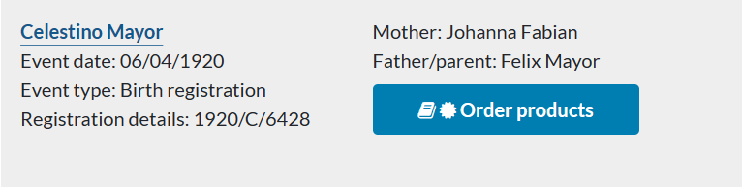
Australian Military Forces – World War II
Tino Mayo
Service No.: DX882
Date of Birth: 6 May 1920
Place of Birth: Thursday Island
Next of Kin: Thomas A. Mayo
Address of NOK: [Service No.] D404, Area HQ Larrimah, Northern Territory
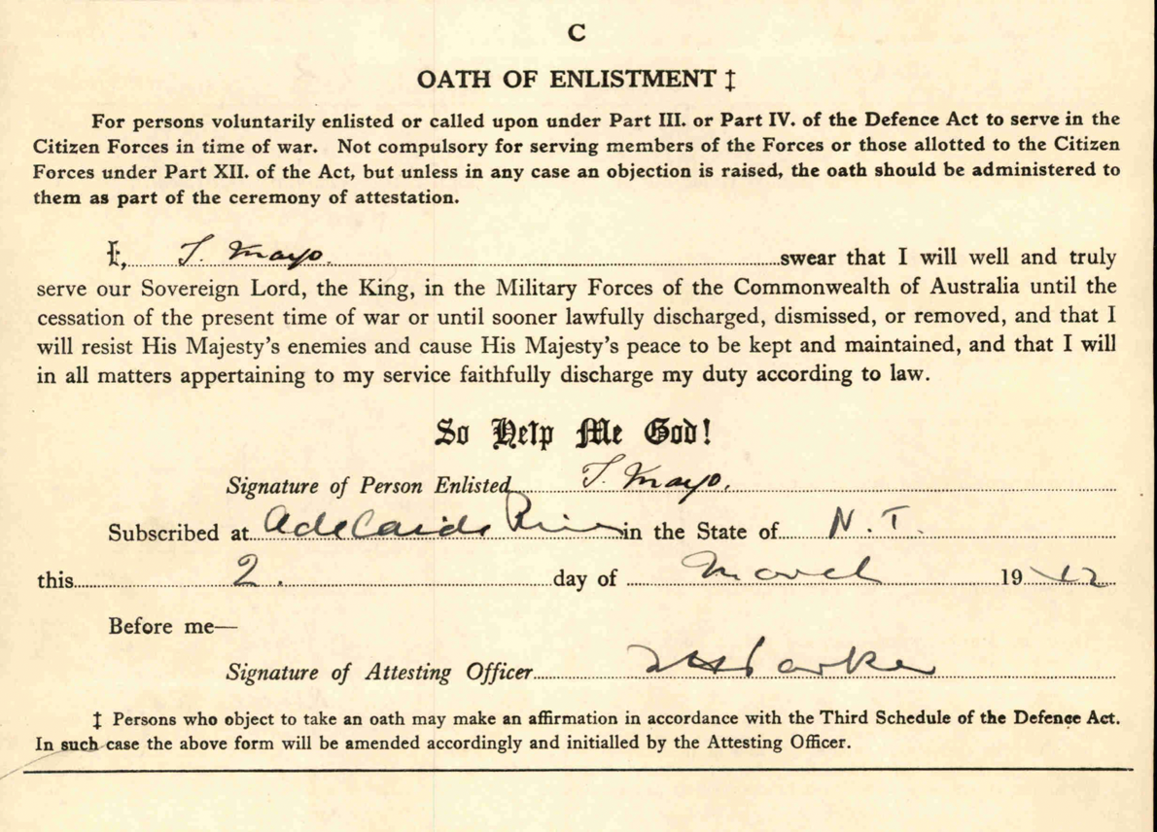

1968 Death Torres News, 31 December 1968, p. 11
The death occured [sic] last Monday 23rd. [sic] December of well known Thurs. Isld .identity Mr. Tino Mayo aged 48 yrs.
Tino who was a crew member of
the coastal vessel Korara, was on annual leave & holidaying with friends & relatives on the island
at the time of his death.
He was born on the island & received his education at the O.L.S.H school leaving the island during the evacuation he was a regular visitor to the island.
Deepest sympathy is extended to his brother Mr. Tony Mayo & other relatives on T.I.
1969 Funeral Torres News, 7 January 1969, p. 5
The funeral feast of the late Tino Mayo was held at the home of Mr. & Mrs Budden Ah Mat on Saturday afternoon.
1971 Feast Torres News, 7 December 1971, p.18
Mrs S. Mayor and family request the pleasure of those who sent cards and floral tributes of sympathy and those who attended the funeral of the late Mr Tony Mayor and Mr. Tino Mayor
to their Tombstone Feast at the Catholic Hall on the 11th December.
Time 4 30p.m.
1971 Feast Torres News, 14 December 1971, p.3
Over 200 guests were entertained at a special feast at the Catholic Hall last Saturday evening when Mrs Shiela [sic] Mayor, her family and relatives marked the occasion of the blessing of the tombstone of her late husband, Mr Anthony Mayor and her brother Mr Celestino (Tino) Mayor.

Notes 5: Johanna PAVIAN / FABIAN
Marriage of Felix Mayor and Johanna Pavian/Fabian
1907 Marriage QLDBDM# 1907/C/2657
Date of Marriage: 5 August 1907
Place of Marriage: Thursday Island
Felix Mayor, Bachelor
Place of Birth: Infanta Zambales, Philippine Islands
Occupation: Sailor
Age: 30
Father: Adriano Mayor, Farmer
Mother: Antonia Nigalang

Johanna Pavian, Widow
Place of Birth: Thursday Island, Somerset, Queensland
Age: 20
Father: Leon Pavian, Sailor
Mother: Philomela Kadola
1903 Marriage QLDBDM# 1903/C/1915
Previous Marriage at age 16
Johanna Pavian m. Emilio Pelayo
Date of Marriage: 7 October 1903
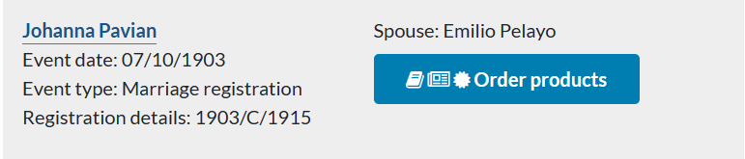
Note: No death details found

Notes 6: Gregorio Leon PAVIAN / FABIAN and Philomona KADOBA
1888 Marriage QLDBDM# 1888/C/2018
28 June 1888
Thursday Island

Fabian Gregorio, Bachelor
Place of Birth: Culebo [Culebra/Colebra?], Phillipine Island
Occupation: Diver
Age: 35
Father: Vicente Molan, Mariner
Mother: Patrona Gregorio

Philomona Kadoba, Spinster
Place of Birth: Mobiac [Mabuiag], Jervis Strait
Age: 24
Father: Woosarkie
Mother: Toemacap
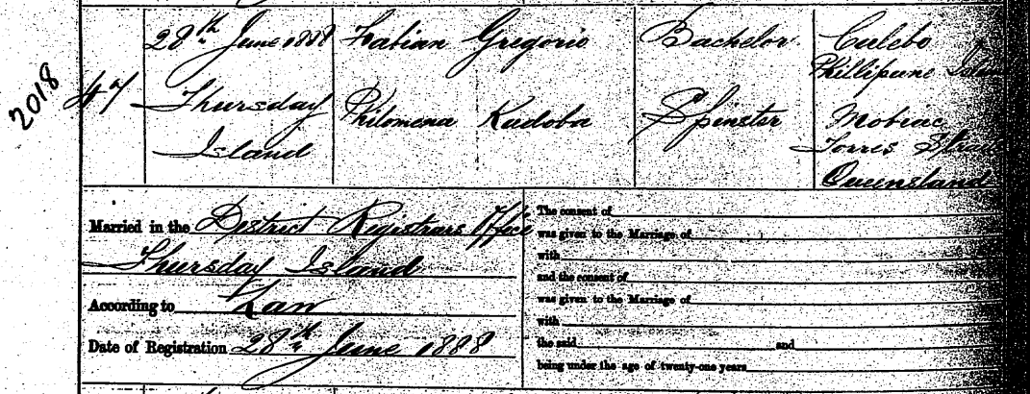
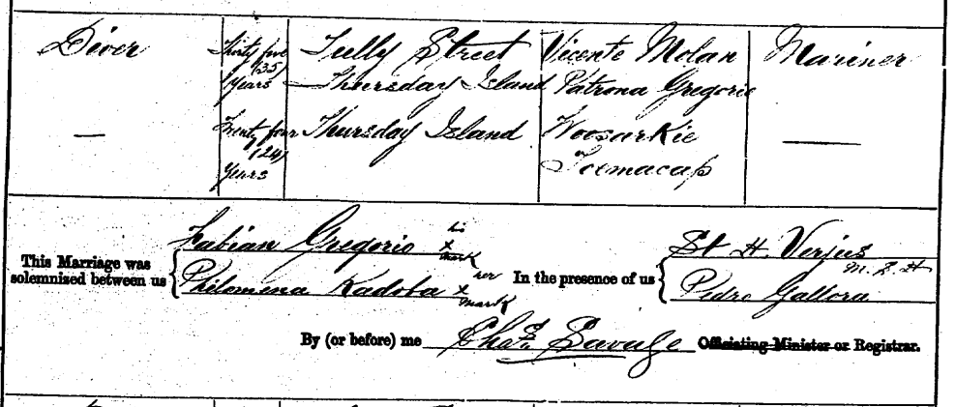

Note: Mabuiag (formerly known as Jervis Island or traditionally known as Gumu), is an island in the Bellevue Islands, 100km north of Thursday Island.
1901 Death QLDBDM# 1901/C/4235
Leon or Gregorio Fabian
Date of death: 8 October 1901
Father: Vicento Molan Fabian
Mother: Patrona Gregorio
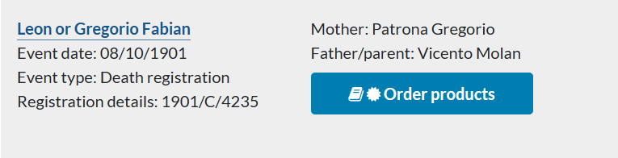

Notes: Source: Navigating Boundaries
Chapter 4: They don’t know what went on underneath
Three little-known Filipino/Malay communities of Torres Strait
by Anna Shnukal
p. 91
In fact, at least five years before the discovery of gold in the eastern part of Horn Island, the ‘Malayans and Filipinos’ had established a small outstation for themselves on the north-west foreshore ‘from the location of today’s Wongai Hotel along the beach to the site of the present wharf complex’. In October 1889, a few months after his naturalisation, the Filipino diver, Pedro Galora, known locally as Peter Manila, and his wife, Clara Gonelai from Mabuiag (Jervis Island), were living in their own house on Horn Island. They may even have moved there soon after their marriage in June 1888, on the understanding that Galora’s application for a lease would be approved. Thursday Island Courthouse records and the Somerset Register of Births attest that also squatting there between 1889 and 1890, when the situation was regularised by the granting of Galora’s lease, were four of his countrymen, who formed the nucleus of the community: Raphael Louis Castro (Louis Manila) and Caroline, his Aboriginal wife from Somerset; Gregorio Leon Fabian (or Pavian) and his wife, Kuruwara Philomena from Gebar (Two Brothers Island), whose third child, Clara, was the first child born to the community in 1889; Pablo Remedio and his wife, Caroline from Mer (Murray Island); and Ramon Roas and his wife, Mary Ann Kass (or Kias) from Mua (Banks Island).

Centre for Philippine Concerns Australia (CPCA)
Pre-war Filipino communities in Torres Strait
by Dr. Anna Shnukal
The first settler on Horn Island in c.1888, Pedro Galora, was soon joined by Raphael Louis Castro, Gregorio Leon Fabian (or Pavian), Pablo Remedio and Ramon Roas and their locally–born Indigenous wives.
The community grew steadily to about 150 in 1895, after which there was a gradual decline to 42 in 1903, followed by an increase to 73 in 1906. Almost 70 births were recorded between 1889 and 1932, the year before the opening of the new Catholic Church, built by the residents and ‘nestled away under the cocoanut trees’, with a bamboo floor, cocoanut thatch walls and an iron roof.
Members of both communities were evacuated to mainland Australia in 1942 and few returned. Nevertheless, the Tagalog words which have entered Torres Strait Creole and dishes like dinaguan [the Filipino dinuguan], thought to be traditionally Islander, demonstrate their influence on Torres Strait Islander custom. Marriage, adoption, shared experiences and friendships link Filipino-descended families with hundreds of other northern Australian families. In Torres Strait several thousand descendants of those early settlers, while proud of their Filipino heritage, identify primarily as Torres Strait Islanders, the second group of indigenous Australians.
Sister: Clara Fabian (Parian, Pavian)
Source: Centre for Indigenous Family History Studies
Marriage Application Correspondence 1915
Chief Protector of Aborigines Correspondence
Correspondence for Marriage Applications 1915
Item ID 336453
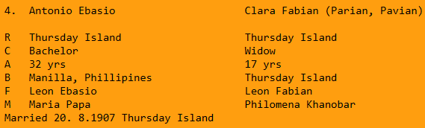

Sister: Maria Pavian
Source: History of Our Lady of the Sacred Heart School Thursday Island 1887-2012
by Br Barry Lamb FMS
p. 82
Some students, 1901-1920
The following names are taken from the Register for the Orphanage and so do not include the day children. The names of the day children may have been lost.
Name: Maria Pavian (called Sylvia)
Born: Horn Isl.
Received: Mar 1906
Dismissed: deceased

Maria/Sylvia’s death QLDBDM# 1920/C/1252
Silvenia Fabian
Date of death: 20 February 1920
Father: Leon Fabion
Mother: Felemino Teruba
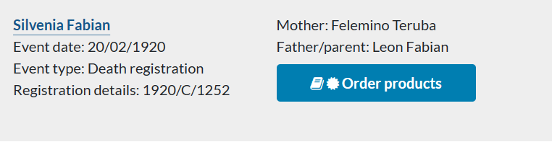

Notes 7: Sheila Walters AHWANG / AH WANG
C1950 Marriage No Marriage record found
1954 Residence Australia, Electoral Rolls, 1903-1980
Mayor, Anthony, Hargreave st., Thursday Island, seaman
[Brother] Mayor, Celestino Michael, Thursday Island, labourer
Mayor, Shiela Warters [Walters], Hargreave st., Thursday Island, home duties
1958 Residence Australia, Electoral Rolls, 1903-1980
Mayor, Anthony, Hargreave st., Thursday Island, seaman
Mayor, Shiela Warters [Walters], Hargreave st., Thursday Island, home duties
1963 Residence Australia, Electoral Rolls, 1903-1980
Mayor, Anthony, Hargreave st., Thursday Island, seaman
Mayor, Shiela Warters [Walters], Hargreave st., Thursday Island, home duties
1968 Residence Australia, Electoral Rolls, 1903-1980
Mayor, Anthony, Hargreave st., Thursday Island, seaman
Mayor, Shiela Warters [Walters], Hargreave st., Thursday Island, home duties
1969 Raffle Winner Torres News, 9 September 1969, p. 15
The Church of England Cathedral, Fete held last Friday evening was a huge
Success….
Winners of raffles are as follows: ….
Water Set. S. Mayo
1972 Travel Torres News, 8 August 1972, p. 7
Mrs Sheila Mayor left on Friday to enjoy the show weekend at Weipa.
1974 Travel Torres News, 27 August 1974, p. 4
Mrs. Shiela [sic] Mayo and family were passengers to Weipa last week, whore she will visit friends and also attend the Annual Show Her brother Mr. Thomas Ahwang was also a passenger to Weipa last week for the show.
1975 Travel Torres News, 1 April 1975, p. 7
Mrs. Sheila Mayo and son William left last Thursday to enjoy the Easter holidays with relatives in Woipa [sic].
1975 Travel Torres News, 7 October 1975, p. 7
Home after enjoying the Weipa Show are Mr. & Mrs Thoma Ahwang, Mrs Sheila Mayo and Mrs Clara McGrath. All were guests of relatives during their stay in Weipa.
1978 Raffle Winner Torres News, 23 May 1978, p. 22
Mrs. Sheila Mayo enjoyed the football tray last Friday.
1980 New Home Torres News, 23 December 1980, p. 25
The latest two homes built by the M.A.W. Housing Corporation at its John Street complex were officially opened last Wednesday afternoon, 17th. Dec. Mr. Connie Filey, representing the Corporation, handed ever the keys of the two homes to their new occupants Mrs. Sheila Mayo and Mrs. Orepa Luffman.
Before the handing over ceremony the homes wore blessed by' the Rev. Peter Tapau and then short speeches were made by the Manager of the Corporation, Mr John Majid, and by Mrs. Sadie Lohan. A common theme of their speeches was the continuing need for such housing on Thursday Is. A special acknowledgement was also paid to the contribution of Mr. Bob Wardell, the Corporation’s building supervisor.
Attending the ceremony were friends of Mrs. Mayo and Mrs. Luffman, representatives of M.A.W. and the B.A.A, members of the building gang responsible for erecting the new homes and members of the crew of the “Torros Venture".
After the official part of the afternoon was over, everybody enjoyed refreshments provided by Mrs. Mayo and Mrs. Luff man.
The homes are the latest erected in a building program undertaken by the M.A.W. Corporation. Nine new homes have boon erected on Thursday Island, Horn Island and Kubin village in Moa Island.

Grandson: Celestino Mayor (Pilot)
Support shown for maiden solo flight – Torres News, 15 August 2003, p. 17
Parents: Thomas Mayor and Maryann Ahwang

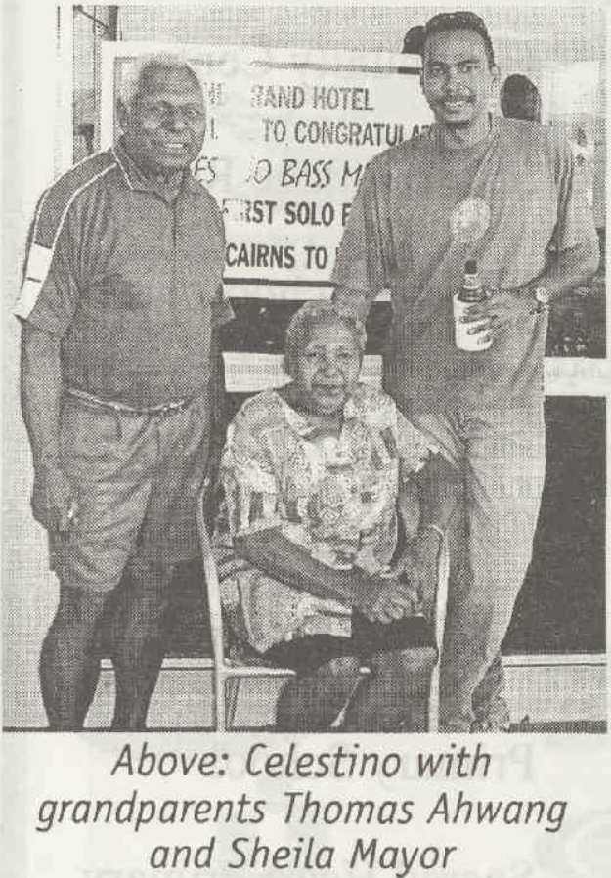

Tombstone Sheila Walters Mayo
(nee AHWANG)
19.12.1928 – 21.11. 2019
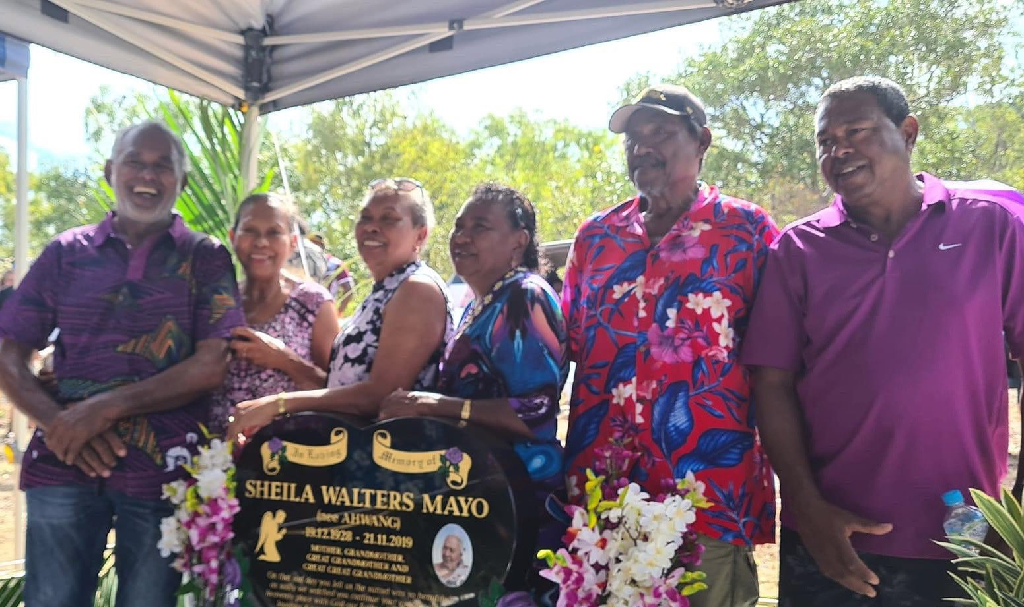

1928 Birth Source: Research by Dr Anna Shunkal 26/9/2002
3 Children of Saptu & Leila Walters Ahwang
3.4 Sheila Walters Ahwang b. 19/12/1928 at Thursday Island m. Anthony Mayor c. 1949 at Thursday Island
Ancestry user NatalieJaeL originally shared this on 25 Aug 2017

Notes 8: Saptu AHWANG / AH WANG
1895 Birth QLDBDM# 1906/O/932
Saptu Wang / Saptu Ah Wang
Date of Birth: 13 September 1895
Father: Ah Wang
Mother: Annie Savage
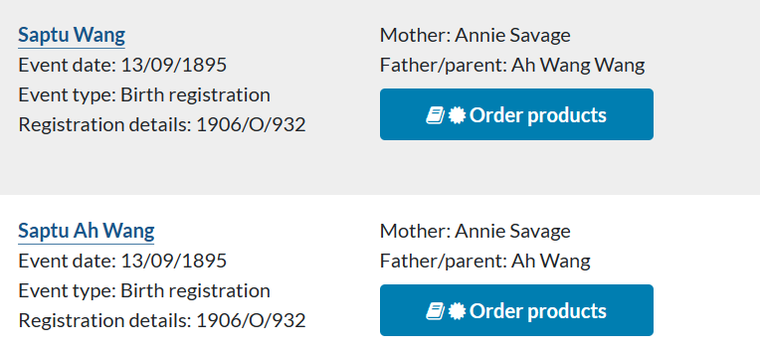
1920 Marriage QLDBDM# 1920/C/2720
Saptu Ahwang m. Leila Walters Motlop
Date of Marriage: 26 July 1920
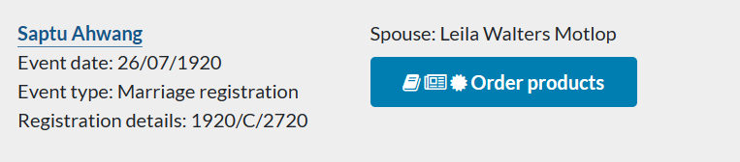
1976 Memories Torres News, 29 June 1976, p. 19
Mr. Joe White Returns…
He worked in the Fresh Food and Ice Co. in the butcher shop section with Mr. Sapto Ahwang, the firm was owned by Mr. Reilly…..
[Afternoon tea]… Mr. Sapto Ahwang couldn’t attend as he was not in the best of health.

1976 Death QLDBDM# 1977/C/1595
Saptu Ahwang
Date of Death: 8 October 1976
Father: Ahwang
Mother: Annie Savage
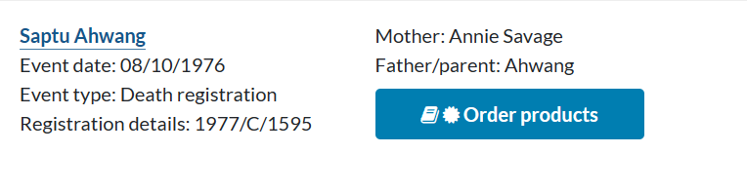
1976 Death Torres News, 26 October 1976, p. 16
The death occured [sic] at the local hospital on 8th. October, of one of T.l's senior citizens. After a long illness Mr. Saptu Ahwang aged 81 years passed away. Deepest sympathy is extended to his sister Mrs. S. Bin Awel, his brother Rocky, who came from Bundaberg for the funeral and his son Mr. Thomas Ahwang and family.

Family Information Source: Research by Dr Anna Shunkal 26/9/2002
2 Children of Ahwang & Annie
2.3 Saptu Ahwang b. c. 1895 at Badu d. 8/10/1976 at Thursday Island m. Leila Walters Motlop 26//1920 at Thursday Island
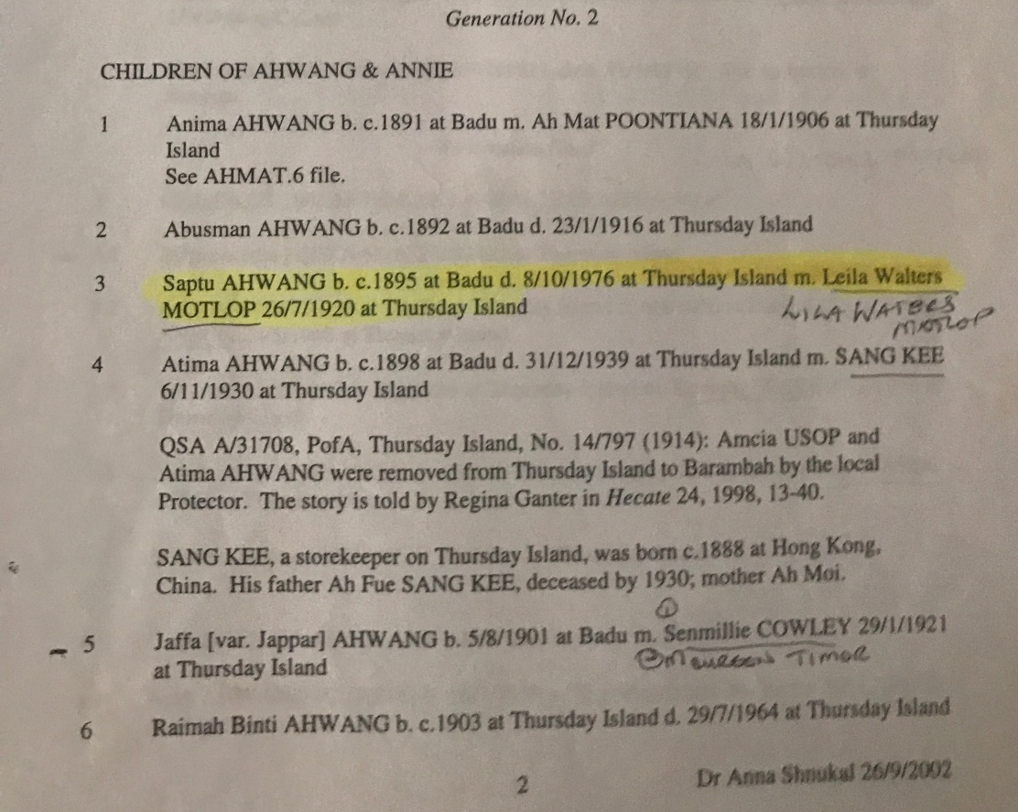
Ancestry user NatalieJaeL originally shared this on 25 Aug 2017

Notes: Birth
Source: Navigating Boundaries
Chapter 4: They don’t know what went on underneath
Three little-known Filipino/Malay communities of Torres Strait
by Anna Shnukal
Table 4.3: Children born on Badu to Malay fathers, c. 1891-1921 – p. 105
C 1895 Saptu
Table records:
Jaffa Ahwang – Place of Birth: Singapore
Annie Savage – Place of Birth: Badu

Marriage
Source: Navigating Boundaries
Chapter 4: They don’t know what went on underneath
Three little-known Filipino/Malay communities of Torres Strait
by Anna Shnukal
p. 110,111
The Malays who initiated their own community at Port Lihou had, like their countrymen, been drawn to Torres Strait by employment in the marine industries. Once there, they married local women of mixed descent and became aware of an opportunity for economic self-sufficiency in agricultural rather than marine activities by taking over the gardens made by the Pacific Islanders. They shared the latter’s desire to ‘reside where they were their own agents and did not come under the control of the Aboriginal department’. The Pacific men did not want Europeans living nearby, but raised no objections to the Malays, with whom they had established good relations over the years. Family bonds were created between the two groups when, in 1920, the step-daughter of one of the original Pacific Islander settlers married Saptu Ahwang, born on Badu to a Malay father. The couple briefly resided at Port Lihou in the mid-1920s.

Notes 9: Jaffa AHWANG / AH WANG or Ahwang Dai
1891 Marriage QLDBDM# 1891/C/1846
- Ah Wang m. Annie Savage
Date of Marriage: 3 June 1891
1935 Death QLDBDM# 1935/C/3497
- Ahwang
Date of Death: 18 July 1935
Father: La Mat
Mother: La Hant
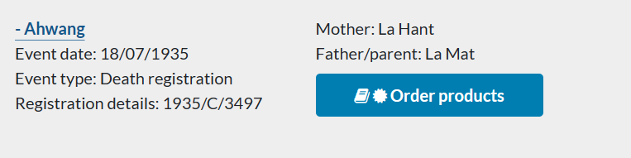

Family Information Source: Research by Dr Anna Shunkal 26/9/2002
Ahwang (Jaffa Ahwang or Ahwang Dai)
Parents
La Mat (boat builder) & La Hant

Generation No. 1
JAFFA AHWANG or AHWANG DAI
b. c. 1862 at Singapore, Straits Settlement
d. 18/7/1935 at Thursday Island
m. ANNIE SAVAGE 3/6/1891
According to Ganter 1998, 19: AHWANG or AHWANG DAI b. c. 1860, a Dayak, the son of a boatbuilder in the Singapore Straits Settlement came to TS through Singapore or Hong Kong during the 1880s, one of the men imported as workers in marine industry, moved from Badu to Thursday Island c. 1904 or 1905. However, according to official registers, Ahwang was living on Badu in 1898, 1906, 1909, Thursday Island 1915. He worked as a diver originally and then as crew. Ahwang held a fuel license in 1933.
Ancestry user NatalieJaeL originally shared this on 25 Aug 2017
Photo “Family Portriotah wang savage”
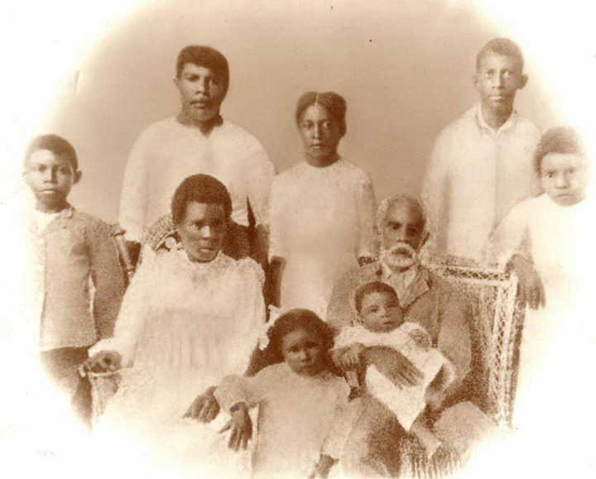
Ancestry user Melissa Studdon originally shared this on 05 Sep 2018
Photo [same photo but from an unknown book and flipped]
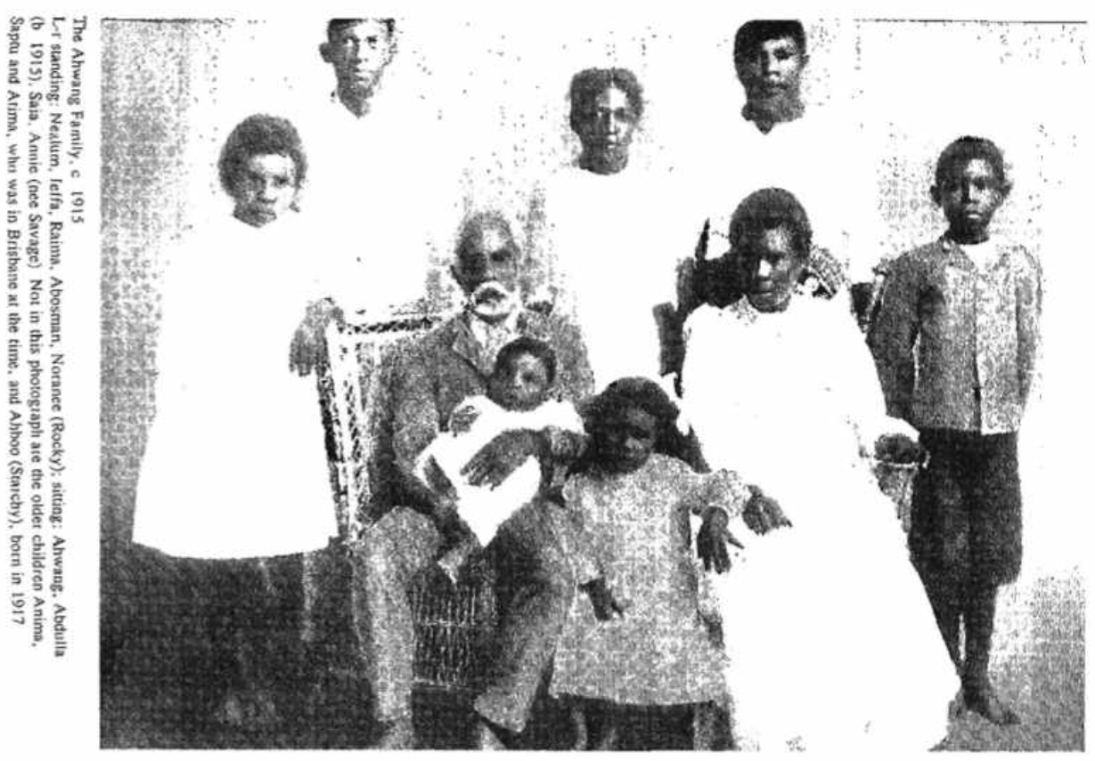
Contributed to FamilySearch by Brian Thomson 12 February 2021

Notes: Marriage
Source: Navigating Boundaries
Chapter 4: They don’t know what went on underneath
Three little-known Filipino/Malay communities of Torres Strait
by Anna Shnukal
p. 120 (References)
[Ref] 121 W. H. R. Rivers recorded three marriages between Malays and Mabuiag women: Mary Gonelai to Ahmat Singapore (Table 1), Aigiwak to Peter (Table 2), Buku to Ketchell (Table 2); and four with Badu women: Annie Savage to Jaffa Ahwang (Table 3A), Serai Mabua to Waahape Jia (Table 8), Baimad Gainab to Albert Bowie (Table 9), Maythaway Baut to Sedin Amber (Table 11). See Haddon, A. C. 1904. ‘Reports of the Cambridge Expedition to Torres Strait.’ Sociology, magic and religion of the Western Islanders, Vol. 5. Cambridge University Press.

Notes 10: Annie SAVAGE
1891 Marriage QLDBDM# 1891/C/1846
- Ah Wang m. Annie Savage
Date of Marriage: 3 June 1891
1956 Death QLDBDM# 1957/C/1175
Annie Ahwang
Date of death: 03/12/1956
Father: Joe Savage
Mother: Sarah Monahou
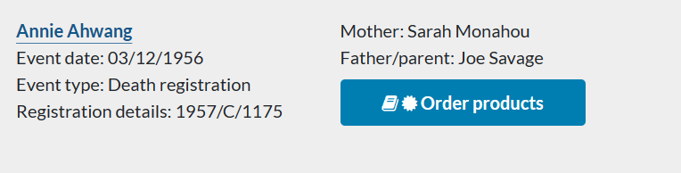

Notes: Marriage
Source: Navigating Boundaries
Chapter 4: They don’t know what went on underneath
Three little-known Filipino/Malay communities of Torres Strait
by Anna Shnukal
p. 120 (References)
[Ref] 121 W. H. R. Rivers recorded three marriages between Malays and Mabuiag women: Mary Gonelai to Ahmat Singapore (Table 1), Aigiwak to Peter (Table 2), Buku to Ketchell (Table 2); and four with Badu women: Annie Savage to Jaffa Ahwang (Table 3A), Serai Mabua to Waahape Jia (Table 8), Baimad Gainab to Albert Bowie (Table 9), Maythaway Baut to Sedin Amber (Table 11). See Haddon, A. C. 1904. ‘Reports of the Cambridge Expedition to Torres Strait.’ Sociology, magic and religion of the Western Islanders, Vol. 5. Cambridge University Press.

Annie
Source: Navigating Boundaries
Chapter 9: Coloured People
A challenge to racial stereotypes
by Regina Ganter
p. 226-227
One of these Asians was Ahwang, or Ahwang Dai, (c.1860–1935), a Dayak, the son of a boatbuilder in the Singapore Strait settlement. In 1891, he married Annie (c.1873–1956), a woman from Badu Island in Torres Strait.24
The Emergence of Legal Distinctions
At the time when Annie married Ahwang, the legislative distinctions between Torres Strait Islanders (Annie’s mother), Pacific Islanders (Annie’s father) and Malays (classed as Asians) resident in Queensland were only just emerging, just as the genetic and cultural differences between them were becoming blurred. (‘Malay’ was a term used for the peoples of Malaysia, Indonesia and Singapore, including the then Dutch East Indies. See Anna Shnukal’s Chapter Four, this volume.) By 1908, an estimated 200 out of 230 residents of Darnley Island in Torres Strait were South Sea Islanders and their descendants. All Torres Strait Islanders were legally Pacific Islanders (‘not under the influence of any civilised power’) until 1872, and those north of 10th degree latitude were so classed until 1879. The first legal distinction was made between Australian Indigenes and other Pacific Islanders with the introduction of the Native Labourers’ Protection Act of 1884, which regulated the employment of Indigenes of Australia and Papua in the marine industries. When the 1897 Aborigines Protection Act was introduced, Torres Strait Islanders were exempted from its provisions until 1904.
When Annie Ahwang’s first three children were born, between 1891 and 1895, being a native of Torres Strait, or of the Pacific, or of the Singapore Strait settlement, made little difference to one’s status as a subject vis-a-vis the State. As British subjects, Malays from Singapore were able to lease land and to become naturalised. When she was having Atima in 1898 and another three babies by 1904, Annie and her husband may have had some news about new legislation affecting Queensland Aboriginal people, though the mainland was far away, and life at Badu was vastly different from the life of camp Aborigines.

Daughter Atima
Source: Navigating Boundaries
Chapter 9: Coloured People
A challenge to racial stereotypes
by Regina Ganter
p. 230-239
The other, apparently similar case was that of ‘Atima Awong’ (Ahwang), age 17, ‘the daughter of a Malay and a half-caste Torres Strait Islander’. Lee Bryce hastened to admit that ‘strictly speaking she does not come under the Aboriginal Act but she and others similarly situated have been treated as being under the control of the Protector’. Atima was about to marry a Malay engaged by a pearling company when Lee-Bryce informed her and her father that permission was required. Ahwang, evidently in favour of his daughter’s marriage to a compatriot, and keen on steering his family away from the paternalistic infringements of the State, ignored this instruction and proceeded with a ‘Malay fashion’ wedding. Lee-Bryce speculated, ‘I strongly suspect she has been married “Malay fashion” on more than one occasion.’
Relying on official documentation, it is difficult to ascertain what a ‘Malay fashion’ marriage was, except that it clearly was not an officially sanctioned wedding. The wedding was backed by the spouse’s employer, Reg Hocking, a pearling master in Australia and Dutch New Guinea, who was also the Honorary Dutch Consul, and who is very likely to have had some familiarity with Malay customs. About Lee-Bryce’s familiarity with or tolerance of Malay customs, we can only speculate. Certainly, the Chief Protectors in Queensland after Roth were administrators and not ethnographers, and to refer to a ‘Malay fashion’ marriage was clearly an expression of disapproval for unsanctioned cohabitation.
Atima and her spouse, now living as man and wife, had undermined the Protector’s authority, and Lee-Bryce put his foot down. He resolved that the marriage was not to be sanctioned or recognised, and the couple should be torn apart. Knowing that Atima was not actually within his domain of powers, LeeBryce recommended that ‘the Minister will strain the interpretations of the Act and order the removal of Atima to a southern settlement — it will be for the girl’s good and serve as an example to others’.
The entry in the Removals Register, recording the removal of Saya and Atima from Thursday Island to Barambah, reads: ‘For their own protection. Living immoral lives.’ Both young women were sent into exile for several years for wanting to marry the men who met with the approval of their fathers…..
Illegal Removal
According to her employer, Atima was a highly regarded and well-protected domestic. She had worked for several respected White families on Thursday Island. Her employer, Mrs Riley, wrote:
this girl Atima has been the best servant I have ever had including white and black and during the whole term of service with me I have not one black mark against her. She was industrious, faithful and most trustworthy and why such an extreme action has been taken I fail to see. People here who have employed her such as Mrs K. O. Mackenzie, Mrs Allan (shipping master) and others are like ourselves very incensed at the action as they all know what an extremely good girl she has been.4
Mrs Riley explained that Atima lived with her parents, and one of her family waited for her in the Rileys’ kitchen every evening to walk her home. On the afternoon of 16 June, 1914, she had taken her employer’s children for a walk to her parents’ house when two plain-clothes policemen appeared to arrest her, walked her to the watch-house by a back way, kept her locked up all night and placed her the next morning on the ship to Brisbane. She had been given no warning of her arrest, no opportunity to pack a suitcase or to ‘purchase one solitary warm stitch of clothing, consequently she has been freezing ever since she left here’. (Barambah, now Cherbourg, near Brisbane, would have been very chilly in June/July.) Nor were her employers warned of her impending arrest, nor any arrangements made for the children who were in Atima’s charge at the time. When the policemen appeared at her employer’s home at 4pm, her employer protested against her removal, and promptly telexed the Home Secretary, A. G. Appel, before the close of business on the same day, arguing that Atima was under legal agreement until October and that her removal was ‘unjustifiable and drastic’. Mr Riley was under the clear impression that the removal order had been signed by Appel.
In response to this pressure, the police were asked to explain the ‘drastic action’, and the constable in charge declared that he had received the minister’s order for Atima’s deportation per steamer Changsha on 16 June, only a day before its departure. Two things are amiss with this explanation. The Changsha was only one of the three monthly steamer services connecting Thursday Island with Hong Kong, Manila, Japan, Singapore and the southern ports of Australia. Transportation to Brisbane could not have been very difficult in almost any week of the year. Moreover, the minister’s orders for the removal of Atima and Saya were not signed until 28 September, 1914, long after the removals were effected. It is possible, but undocumented, that an order for Atima’s removal was issued previously by the Acting Home Secretary, A. H. Barlow, on 2 May, 1914, as Chief Protector Bleakley later claimed, but it is not clear why in that case a second order had to be issued retrospectively in September.
Being under a legal agreement to an employer placed Atima outside the ambit of protectors’ powers for removal according to Section 10a of the 1897 act (even if it had been agreed that she was included under this act at all). To stifle possible embarrassment in the face of the inquiries instigated by Riley, the entire administration, including the Under Secretary of the Home Department, considered that ‘the matter can be best adjusted by allowing Mr Riley to engage another girl’. The Rileys, however, argued that they had no need for another domestic. They entertained close links with the Ahwang family and wished Atima to be returned to their service, and for several months Mrs Riley refused to employ another domestic. In her correspondence and exchange of parcels with Atima, she claimed that ‘we still do all our own work and no one to help us’.
Atima became the subject of a personal consultation between the Home Secretary and Chief Protector Bleakley, with the result that the administration rallied behind the local Protector’s stance because
the removal of Atima and Saya had a great moral effect, but if they are not detained for a few years my influence with the coloured population will be seriously affected.
This removal was clearly ultra vires, and the bureaucracy was fully aware of this. The Chief Protector informed the Home Department:
From the facts that the girl was a quadroon Malay and legally under
agreement at the time she was really exempt from removal, but the
Protector apparently acted in the interests of discipline and morality and it
is certainly expedient that this action, though perhaps not entirely correct,
should be upheld.
The more pressure was placed on the administration, the more determined it became to stand its ground. To the intervention by Douglas, the local Protector replied:
it is quite evident Mr Riley has decided to ignore me and endeavour to obtain what he desires through other channels … It has been well known here for some time that Mr Riley was using every influence at his command to secure the object he has in view and if his request is granted my position will be considerably weakened in the eyes of both the white and the coloured population.
In this entire correspondence, no shadow of doubt was cast on Riley’s good character that would justify the action taken. The ‘object he had in view’ was Atima’s return into his wife’s employment. Riley fell foul of the administration because he challenged the bureaucracy. The Protector strongly advised that Atima should not be allowed to return.
Despite all efforts on her behalf, Atima was now fully in the grip of the act. When she asked for 10 shillings out of her earnings to send to her ailing father, the Brisbane protectress passed on the request to the Chief Protector. The Chief Protector, also unable to reach a decision by himself, consulted the local Protector on Thursday Island, who considered that ‘The father is not in need and could probably do light work if he cared to’.
Much doubt was cast on the character of Atima’s father in this correspondence, referring to his gambling habit. He engaged in the very popular Thursday Island pastimes of chiffa, ‘luk-luk pat’, and other games. His fortunes rose and fell and he may in times of need have leaned on his children. According to his two surviving sons, he amassed the wealth to buy a house on Thursday Island through gambling, and lost it in the same manner. With the removal of Atima, the whole family became subject to the paternalistic rhetoric that was part of the discursive culture of the department, where it was quite common to make unsubstantiated detrimental comments about people’s lifestyles. (One of the protectors, steeped in this rhetoric, had to be reminded by another department with which he was corresponding after World War II that his incriminating comments about the living conditions of an Aboriginal/Japanese/Chinese family were ‘irrelevant for the decision to be made’.)
After Lee-Bryce’s death in December 1916, Mrs Riley resumed her lobbying efforts. The acting Protector supported Atima’s release, but Bleakley insisted that she serve out her current contract as a domestic in Brisbane. He argued that ‘The girl appears very happy and well looked after in her present place’, that Mrs Riley was placing unwarranted pressure on her, and that
Atima informs me she wishes to visit Thursday Island, but only for a holiday, in about six months time, after the wet season, and when she has saved sufficient to pay for her trip.
Atima’s own letter to the Chief Protector the next month put the lie to this interpretation:
Dear Mr Bleakly, just a few lines to let you know that I made up my mind to go back to Mrs Riley again when my times up. I think she done her best to get me back since I been away from her place and I like her very much. I was quite happy with her. Also Mrs Cameron. And I think I been here long enough with Mrs Cameron. So I would like to know if you let me go back to Mrs Riley for good. I rote to her and told her that I was going to ask you to let me go back. So I have nothing more to say. Your faithfull Atima Ahwang.
This is likely to be as determined as a 19-year-old dared to be with the Chief Protector. Atima returned to Thursday Island after more than three and a half years of exile, but she was unable to shake off the shadow of the bureaucracy’s watchful eye over her personal affairs.
A Matter of Definition
At some time in 1919, Atima had a baby and it appears that she came under some pressure to enter into a marriage. In June 1919 and in March 1920, applications were made for the marriage of Atima by two different candidates, both of whom the bureaucracy would have considered ‘suitable matches’. Both marriages were approved, but neither of them took place. Atima seemed quite keen now to escape the arm of the department. In her first marriage application, she claimed to have been born on Thursday Island. Forwarding this application, the new Protector pondered:
It is questionable whether either of the applicants come under the Aboriginal Act — the former [Atima] having been signed on under the Act for some years I think it better to be on the safe side, and obtain your consent.
The department remained ‘on the safe side’ and held vigil over this woman. In September 1920, the local Protector questioned her about her intended marriage and, within a few weeks, Atima, very likely now tired of this moral persecution and following her older brother’s example, evidently decided to clear her status once and for all and applied for formal exemption from the act. Although the department had always been of the opinion that she was not ‘strictly speaking’ under the act, her application was refused. Subscribing to the ‘safe side’ logic, the refusal was justified as follows:
it does not appear that being under Departmental control inflicts any hardships upon the girl and on the other hand apparently no additional benefit would accrue to her from being exempt from supervision.
No hardship, indeed! She had been exiled for more than three years, barred from marrying, had her wages banked by the department, had been questioned by officials about her romantic involvements and had been cast as immoral.
Atima’s application for exemption was supported by letters from Walter Filewood, the union representative, addressed personally to Home Secretary McCormack (‘trusting this finds the labour party a successful term of office’), to Chief Protector Bleakley (‘regards to you and your brother Charles’), and to the local member, Ryan (‘I conduct his election business’).
Going over the head of the local Protector was a direct affront to the bureaucracy. The department responded by proceeding against Filewood, who was possibly having an affair with Atima, for ‘harbouring a female half-caste’. To be successful, however, the department needed to first ascertain that Atima was a ‘half-caste’ under the act. This question was not settled in response to Atima’s application for exemption, but in order to proceed against Filewood for harbouring.
The current legal definition of ‘half-caste’ was the offspring of an Aboriginal mother and other than an Aboriginal father (Section 3 of the 1897 act). Section 4 of the act, however, made three further provisions by which ‘half-castes’ could be considered Aboriginal. This was the case if they had been living with an Aboriginal spouse at the passing of the act (Clause b), if they otherwise habitually associated with Aboriginals (Clause c) or if, in the Protector’s opinion, their age did not exceed 16 years (Clause d). Consequently, if it could be argued that Atima’s mother Annie was not a ‘half-caste’, but an Aboriginal, then Atima would be a ‘half-caste’ under the act. Bleakley referred this question to the Home Secretary, already suggesting which decision ought to be reached on the question:
A question has arisen in regard to the position of a crossbreed girl … It is extremely important that the Protector should, if possible, have the power to deal with this case to maintain discipline amongst the numerous crossbreeds under his charge.
The Crown Solicitor was now asked for the first time to consider the status of quadroons under the act. He determined, and a circular (No. 21/6) was sent to all protectors stating that:
A female quadroon comes within Section 14 of the A. P. Acts of 1897 if it can be established that the mother is the offspring of an aboriginal mother and other than an aboriginal father and that she (the mother) otherwise than as wife, habitually lived or associated with Aboriginals.
This meant that such a female could not be harboured without penalty. This did not, however, fully answer the case because of the complicating temporal dimension of the definition. The local Protector now formulated the following questions about Atima for consideration by the Crown Law Office:
[now talking about Annie Savage]
Atima’s mother Annie was the daughter of a native of Madagascar and a full blood native of Badu, and married to a Malay. She lived at Badu Island at the passing of the 1897 act and until 1904 or 1905, but had not since then habitually lived or associated with Aborigines. Was Annie an Aboriginal within Clause c Section 4. It was determined that Annie was Aboriginal from the time of her birth until she left Badu Island in Torres Strait.
The second question complicated the way in which the 1897 act made provision for people to ‘become’ Aboriginal and to ‘become’ ‘half-caste’: ‘Would Annin Savage Ah Wang remain an aboriginal within the meaning of the Act after she left Badu, or would she automatically become a “half-caste” on ceasing to habitually live or associate with aboriginals?’ The Crown Solicitor considered that, on ceasing to habitually live or associate with Aborigines, Annie ceased to be Aboriginal and became a ‘half-caste’.
The third question was whether Annie’s offspring born on Badu were ‘half-caste’, and this was also answered in the affirmative. Of course, the children could be considered ‘half-caste’ only on the strength of their mother being deemed Aboriginal. The mother was now retrospectively classed as having been an Aborigine until 1905.
The fourth question was whether Section 4 in fact provided a feedback loop for endless generations of mixed descendants to be drawn back into the act. If the ‘half-caste’ mother was ‘deemed’ Aboriginal, could the children also be ‘deemed’ Aboriginal under the same provisions? To which the Crown Solicitor replied:
Each of them until in the opinion of a protector he or she was over sixteen years of age, or until he or she ceased to live or associate habitually with aboriginals, was deemed to be an aboriginal under Section 4. On attaining sixteen, or ceasing so to live or associate, he or she ceased to be deemed an aboriginal, and came within the definition of half-caste.
The Protector also inquired about the status of the last two children born on Thursday Island. The Crown Solicitor determined that these were neither ‘half-caste’ nor Aboriginal.
All these determinations depended on Annie having lived on Badu Island, which meant that she ‘must of necessity have habitually associated with aboriginals’. On further inquiry, however, Protector Holmes realised that living on Badu did not necessarily mean associating with Aborigines:
When at Badu I inquired fully into the question of Atima Ah Wang and found that she did not at any time, nor did her mother, habitually live or associate with aboriginals. It appears that the girl’s grandmother lived with her husband, a native of Madagascar, at the South Sea Settlement, so that her daughter Annin Savage, Atima’s mother did not from the time of her birth or at any time habitually live or associate with aboriginals. Her mother is a half-caste female within the meaning of the Act, so that her children are all exempt from its provisions.
This should have been the last we heard of this family in the department’s files. In November 1922, however, an ambitious young protector was appointed to Thursday Island: Cornelius O’Leary, who was to become Chief Protector from 1943 to 1963.
[Atima]
Greater Powers
After only half a year on the island, O’Leary gingerly raised the question of the protection of quadroon females. Atima, having been told by a previous protector that she was exempt from the act, evidently disavowed any power of the department over her. O’Leary felt that this was a bad example, and that the act should be amended to grant him powers to oversee such women
Ever since taking over the position of Protector of Aboriginals here, an outstanding phase of aboriginal life on Thursday Island has been the prevalence of temptation to half-caste or aboriginal girls, who are domestically employed, to go the wrong road. Opportunities for such unfortunates are no doubt great, and I have come to the definite opinion that the temptation is accentuated by the example of many quadroon females who see fit to lead an unhindered and immoral life. There are some half dozen or so of those persons here, probably more who are the unhappy plaything of all and sundry. Even the survey ship ‘Fantome’ supplies small quotas of men who on their periodical visits here promiscuously associate with these females. This phase of the question is officially no concern of mine in that I have no jurisdiction over these females or interests in their welfare … Mr Holmes had one such girl signed on, during his regime, as a half-caste, which was a good move, but the position has now reacted upon me in that an interested person, her present employer, schooled her to the position with the result that both the parties refused to recognise this office after the expiry of the agreement, and she now preaches her doctrine of defiance and immorality to her associates. I have had, on several occasions, to have female and male aboriginals before me for associating with those avowed immoralists, but while they are permitted to live the loose life, the position is difficult in the extreme.
A strong stance is taken here, but as far as factual information goes, this report is sadly lacking. The factual allegation against Atima is that, with the support of her employer, she refused to recognise any authority of the Protector over her. From everything we read about Atima, this position is entirely justified. She appears to have had the consistent support of Whites on Thursday Island to defend her against departmental infringements. O’Leary’s conclusion was that she was defiant and immoral — she and the Whites advocating for her being ‘avowed immoralists’. Of the ‘many’ loose women who allegedly characterised Indigenous life on Thursday Island, there were about six known cases, though the Protector did not really wish to count them, since the ‘half a dozen or so’ were instrumental in arguing for an extension of legal powers. The purpose of O’Leary’s report was to recommend an amendment of the act furnishing protectors with discretionary powers to bring quadroons under the act. O’Leary argued that ‘the result of this amendment is apparent’, allowing for stricter surveillance, and
[f]urthermore, their mistaken idea that they are of equal intellect to the white would be rudely dispelled. There is no doubt that the average female half-caste is quite as intelligent as the Thursday Island quadroon whose associates are solely half-caste quadroon or cosmopolitan.
O’Leary professed to be unaware of whether the question of quadroons had been raised before and asked to be informed of ‘the reasons for their sole exemption from the provisions of the act’. The Chief Protector replied by forwarding a copy of circular 21/6, the Crown Solicitor’s opinion that had been formulated in response to Atima’s case, and regretted that this was ‘apparently the only hope at present of exercising official control of such women’ — by means of ‘deeming’ their mothers Aboriginal.
Chief Protector Bleakley finally asserted his authority with a further amendment of the Protection Act in 1934, which specifically targeted, by his own admission, the Coloured population of north Queensland. Defining ‘half-castes’ now became a tricky mathematical exercise in counting parts of ‘blood’ as well as retaining the social dimension of the earlier definition (habitually associating). The department’s powers now extended over all ‘such women’ whose status under the act had been indeterminate:
the illegitimate children of half-caste mothers, the children of parents both half-castes, and the crossbreed element of aboriginal or Pacific Island strain.
The new act allowed mixed descendants to the fourth generation to be pulled into the ambit of the Protector of Aborigines as ‘half-caste’. The age of ‘half-castes’ ‘deemed to be Aboriginal’ was raised from 16 to 21, and all exemptions from the act were initially revoked with the effect of disenfranchising all those who had held exemptions and had been able to vote in state elections.
At the zenith of the department’s powers, a resistance movement developed, fuelled by Coloured populations. A highly public campaign on Thursday Island protested against disenfranchisement, alleging that Whites had been turned into Blacks. Of 384 registered voters on Thursday Island in 1936, an estimated 70 to 85 were ‘half-castes’. Closely following the objections raised by the Coloured People’s Progressive Association, whose spokesmen were Whites married to Coloured women and three men referred to as ‘half-castes’ (T. Loban, W. H. Dubbins and D. Hodges, a returned soldier), a State Public Service Commissioner’s inquiry contested the propriety of the arbitrary powers assumed by the new amendment act (‘in the opinion of the protector’).
All over Queensland, associations were formed demanding citizenship and, in areas where there were large Coloured populations, strikes were staged against the departmental control of wages in 1936 and 1937. In an attempt to stem the tide of protest from the far north, the 1897 Act with its amendments was replaced in 1939 with two separate pieces of parallel legislation, one for Aborigines and one for Torres Strait Islanders, which granted some measure of self-government to the island communities.

Notes 11: Maivanga 'Joe' SAVAGE and Zarazar 'Sarah' MONAHOU
C. 1886 No Marriage Record found
1922 Death QLDBDM# 1922/C/3144
Joe Savage
Date of Death: 23 June 1922
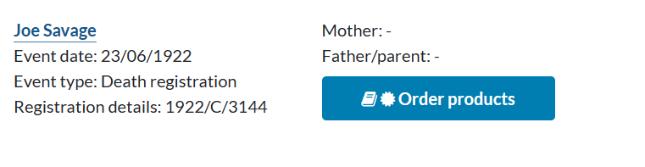
1923 Death QLDBDM# 1923/C/3371
Zaraza Savage
Date of death: 16 June 1923
Father: Mano
Mother: Kodagud
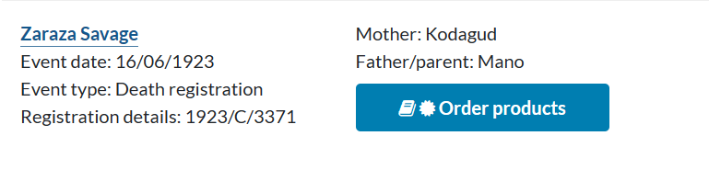
Notes: Daughter Annie
Source: Navigating Boundaries
Chapter 9: Coloured People
A challenge to racial stereotypes
by Regina Ganter
p. 236
….Annie was the daughter of a native of Madagascar and a full blood native of Badu, and married to a Malay.

Source: Navigating Boundaries
Chapter 9: Coloured People
A challenge to racial stereotypes
by Regina Ganter
p. 244 (references)
Ref: 63 ‘Protector Holmes to CPA, 10 August 1921.’ The reference to Madagascar stems from a statement by ‘Annin Savage Ah Wong’ to the police on 1 April, 1921, A/58761, QSA.

Note: Believed that the name Savage originates in Niue
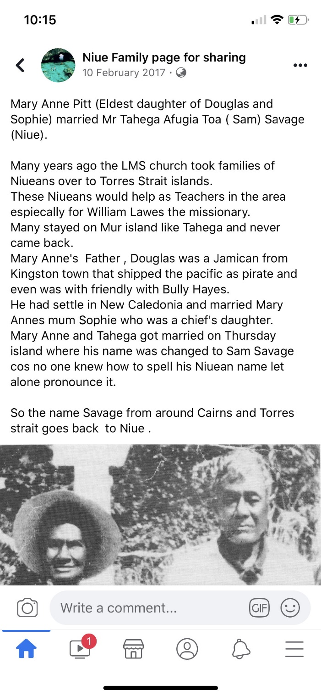
Ancestry user Joshua Hoffman originally shared this on 15 Dec 2019

Note: The family line of four Savage brothers from Torres Strait
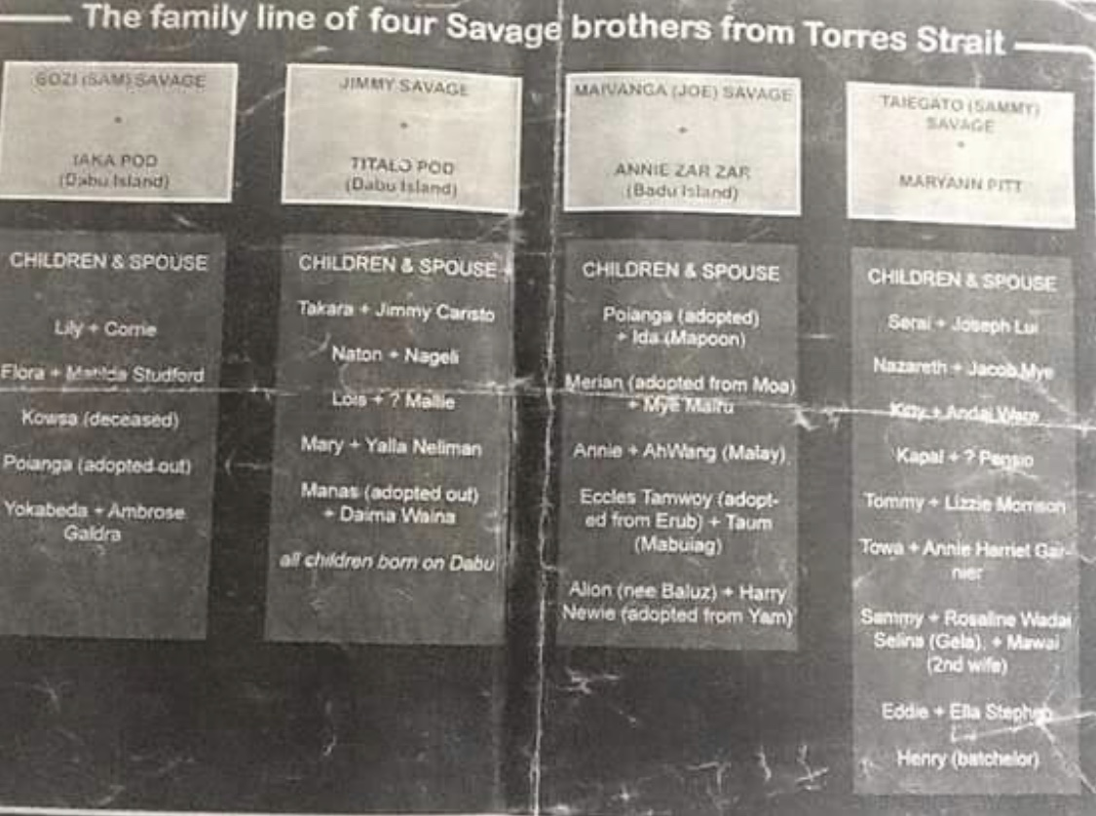
Ancestry user Joshua Hoffman originally shared this on 15 Dec 2019

Notes 12: Leila Walters MOTLOP
1905 Birth QLDBDM# 1906/O/932
Lilla Waters Mottop
Date of Birth: 16 July 1905
Father: Tom Mottop
Mother: Polly Noelke
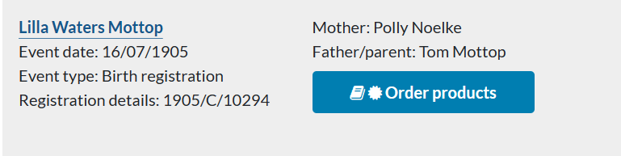
1920 Marriage QLDBDM# 1920/C/2720
Saptu Ahwang m. Leila Walters Motlop
Date of Marriage: 26 July 1920
1944 Death QLDBDM# 1944/C/4454
Leila Walters Ah Wang
Date of Death: 2 December 1944
Father: Tom Motlop
Mother: Polly

1944 Burial Cairns Martyn St Cemetery (FamilySearch)
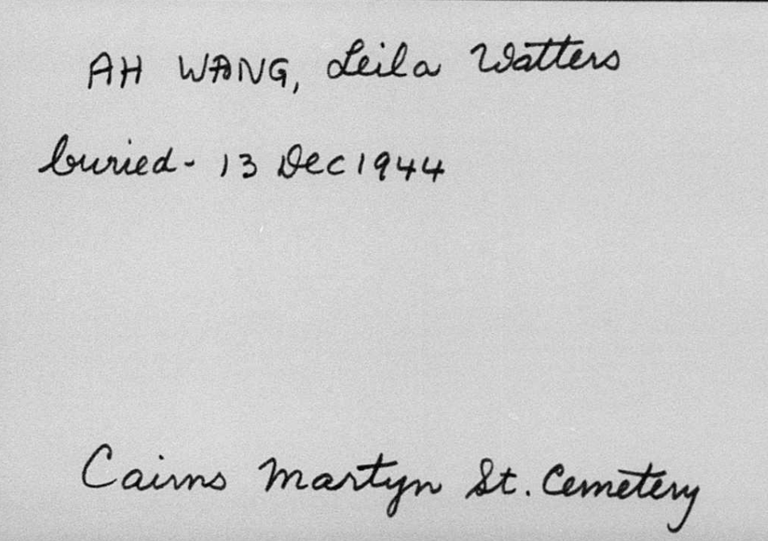

Notes: Marriage
Source: Navigating Boundaries
Chapter 4: They don’t know what went on underneath
Three little-known Filipino/Malay communities of Torres Strait
by Anna Shnukal
p. 110,111
The Malays who initiated their own community at Port Lihou had, like their countrymen, been drawn to Torres Strait by employment in the marine industries. Once there, they married local women of mixed descent and became aware of an opportunity for economic self-sufficiency in agricultural rather than marine activities by taking over the gardens made by the Pacific Islanders. They shared the latter’s desire to ‘reside where they were their own agents and did not come under the control of the Aboriginal department’.141 The Pacific men did not want Europeans living nearby, but raised no objections to the Malays, with whom they had established good relations over the years.142 Family bonds were created between the two groups when, in 1920, the step-daughter of one of the original Pacific Islander settlers married Saptu Ahwang, born on Badu to a Malay father. The couple briefly resided at Port Lihou in the mid-1920s.

Notes 13: Tom MOTLOP / MOTOLAVA
1896 Marriage QLDBDM# 1896/C/1826
12 September 1896
Thursday Island

Tom Motolova, Bachelor
Place of Birth: Motolava, [?], South Pacific
Occupation: Pearl Diver
Age: 27 Years
Father: Dowar Motloava
Mother: Sarah

Polly Knolke, Spinster
Place of Birth: Schooner in Torres Straits
Occupation: Domestic Servant
Age: 20 years
Father: William Knolke, Master Mariner
Mother: Warelipug
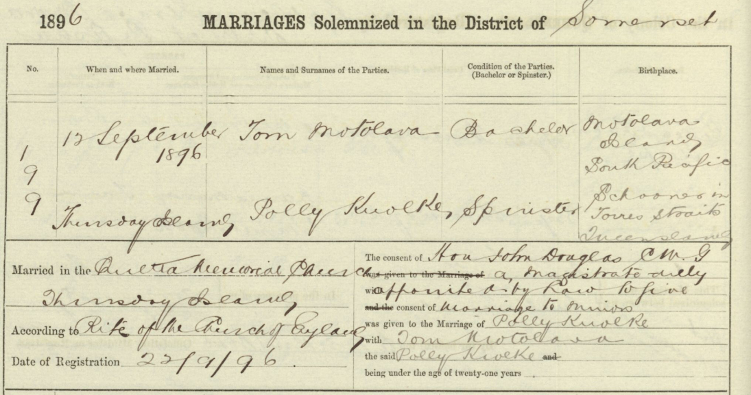
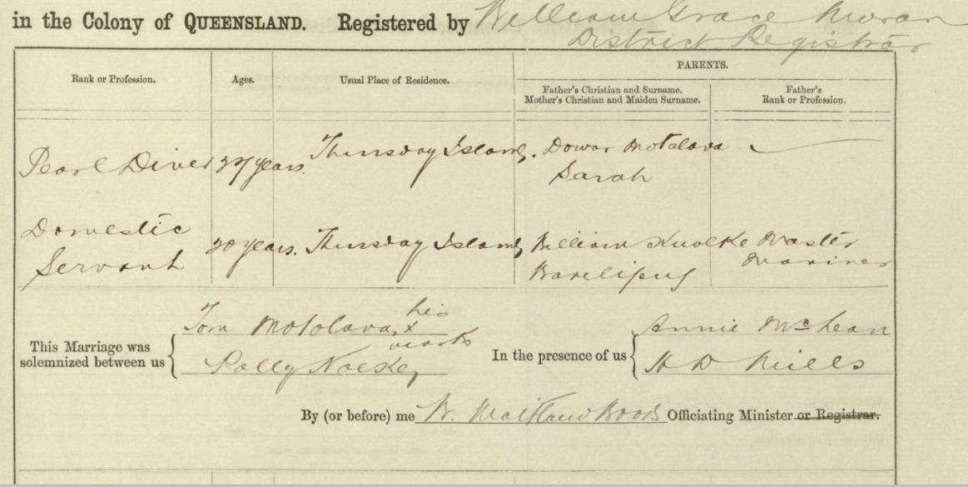
Note: The inhabitants of Mota Lava call the island Mwotlap, locally spelled M̄otlap
Note: Polly’s father was a Master Mariner, place of birth “Schooner” is a boat.

1914 Death QLDBDM# 1914/C/3844
Tom Motolava
Date of death: 25 November 1914
Father: Dowar Motolava
Mother: Sarah
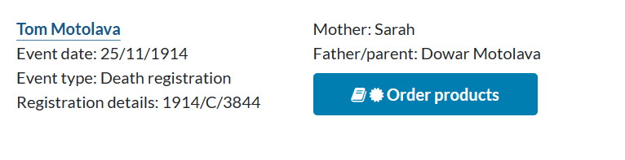
1914 Death QLDBDM# 1914/003844 (Findmypast database)
Motlop
Date of Death: 25 November 1914
Father: Dowar Motolava
Mother: Sarah
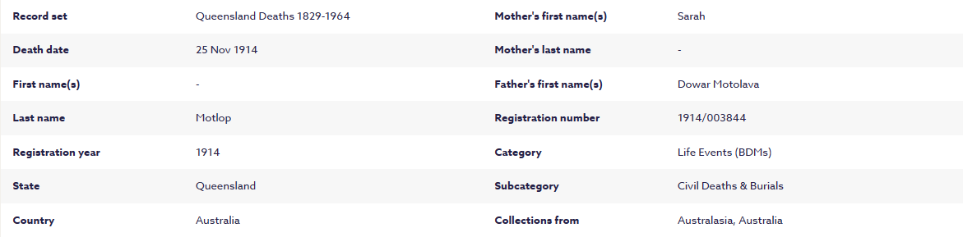

Notes 14: Polly NOELKE
1896 Marriage QLDBDM# 1896/C/1826
12 September 1896
Thursday Island

Tom Motolova, Bachelor
Place of Birth: Motolava, [?], South Pacific
Occupation: Pearl Diver
Age: 27 Years
Father: Dowar Motloava
Mother: Sarah

Polly Knolke, Spinster
Place of Birth: Schooner in Torres Straits
Occupation: Domestic Servant
Age: 20 years
Father: William Knolke, Master Mariner
Mother: Warelipug
Note: The inhabitants of Mota Lava call the island Mwotlap, locally spelled M̄otlap
Note: Polly’s father was a Master Mariner, place of birth “Schooner” is a boat.

After the death of her husband, Tom Motlop, in 1914.
1916 Marriage QLDBDM# 1916/C/2534
Polly Motlop m. Willie Ambrym
Date of Marriage: 7 September 1916
1937 Death QLDBDM# 1938/C/921
Polly Ambrym
Date of Death: 30 December 1937
Father: William Noelke
Mother: Warelipug

Notes 15: William NOELKE
1875 Naturalisation Butts of oaths of allegiance sworn by aliens being naturalised (Queensland)
DR111051 Part 2, p. 9-10
No. 3120
Certificate issued 2 April 1875
William Noelke
Place of Birth: Perleberg, Germany
Age: Twenty seven years
Profession, trade or other occupation: Seaman
President residence: Somerset, Cape York
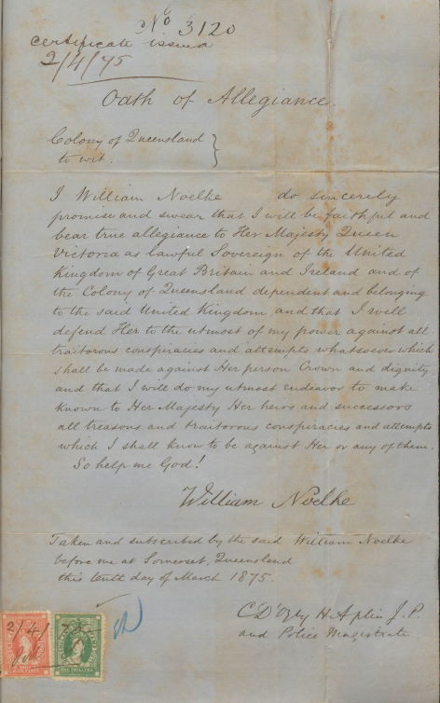
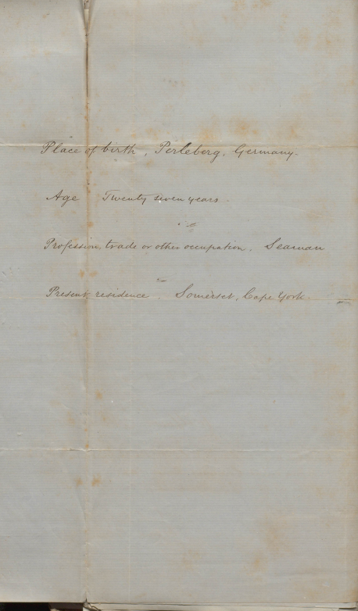
1900 Ship Master The Brisbane Courier, 27 July 1900, p. 4
William Noelke has been appointed master of the Government steamer White Star.
1900 Inspector The Brisbane Courier, 25 October 1900, p. 4
William Noelke, master of the Government steamer White Star, has been appointed an Inspector under the Pearlshell and Beche-de-mer Fisheries Act.

1908 Residence Australia, Electoral Rolls, 1903-1980
Noelke, William, Thursday Island, mariner
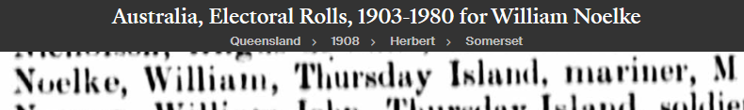
1915 Residence Australia, Electoral Rolls, 1903-1980
Noelke, William, Thursday Island, mariner
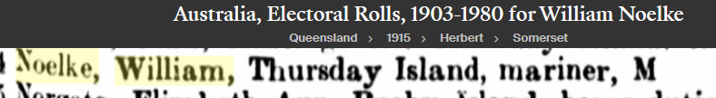
1925 Residence Australia, Electoral Rolls, 1903-1980
Noelke, William, Thursday Island, mariner
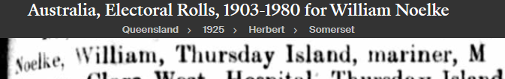
1937 Residence Australia, Electoral Rolls, 1903-1980
Noelke, William, Thursday Island, mariner
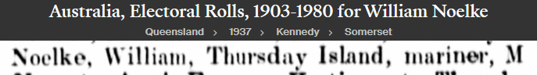
1939 Death QLDBDM# 1939/C/928
William Noelke
Date of Death: 24 January 1939
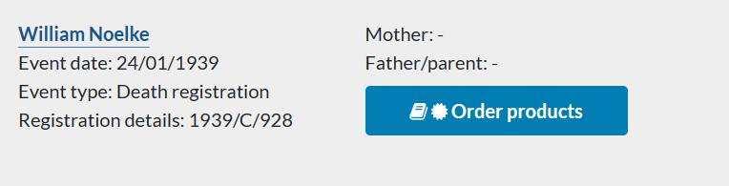
1939 Death The Northern Herald (Cairns), 18 February 1939, p. 49
STRUCK BY CAR.
Nonagenarian's Death.
T.I's. Oldest Resident.
Advice was received by Sub-Inspector G. E. Collyer yesterday of the death of William Noelke, the oldest known resident of Thursday Island, and a familiar figure in shipping circles there for many years.
According to the report received, Noelke, who was 91 years of age, was taking his customary walk along Victoria Parade about 7.30 p.m. when the accident occurred. He was rushed to hospital, where it was found he had both legs and one arm fractured and other injuries, and he died some hours later.
Noelke was born in Perleberg, Germany, but became naturalised 64 years ago. For many years he was master and pilot alternately on overseas ships, and later had charge of a fleet of schooners engaged in pearling in the northern waters.
1939 Death The Northern Herald (Cairns), 22 April 1939, p. 11
TRUCK DRIVER FREED
UNLAWFUL KILLING CHARGE.
THURSDAY ISLAND TRAGEDY.
CAIRNS. April 19.
The story of the tragic death of Thursday Island’s oldest resident, William Noelke (91), a pensioner, was recounted by the Crown Prosecutor (Mr. J. P. Quinn') in the criminal sessions of the Cairns Circuit Court yesterday. Noelke died in hospital as a result of injuries received when he was struck by a motor truck on Victoria Parade while taking his evening stroll on the night of January 23.
Ernest Simpson (52), working foreman of the Thursday Island Town Council, stood in the dock before Mr. Justice R. J. Douglas charged with unlawfully killing Noelke. He pleaded not guilty through his counsel, Mr. R. Cormack, who was instructed by Mr. H. F. McLaughlin
VOLUNTARY STATEMENT.
Mr. Quinn in outlining the circumstances of the case said that the story of the tragedy was best told in the statement of the accused which he had voluntarily given to the police.
On the day of the accident Simpson had been repairing a drain on Victoria Parade. Towards evening it threatened rain and Simpson decided to return to the uncompleted drain works and remove some rocks. He went to the council yards and obtained a utility truck and drove to the spot. Before leaving he tested the lights of the truck and they burned brightly. After removing the stone wall the accused prepared to drive back.
As he was doing so Mrs. Wallace, a cook employed at the Thursday Island Hospital, and her daughter Jean walked along. Simpson then was experiencing trouble with the engine of the truck and Mrs, Wallace held a torch while he repaired a loose connection on the distributor. He then offered to give the mother and daughter a lift on their way to the town.
LIGHTS FAILED.
Starting the engine Simpson found that the lights would not shine. He turned the truck and then proceeded slowly along the road working at the switch to try to connect the lights. He had proceeded a short distance at a slow rate of speed when suddenly Mrs. Wallace screamed and Simpson saw a figure in front of the radiator and felt a slight bump. He braked the truck and stopped instantly. He alighted from the cabin and found a man whom he recognised as William Noelke lying beside the truck. He was moaning and when the accused lifted him to the side of the road on to a grassy ledge complained that his legs were badly hurt.
Simpson went to the Federal Hotel for assistance and brought back a stretcher and cushions to make the old man comfortable. Dr. J. R. Nimmo was called and ordered his transport to hospital. Noelke was placed on a litter in the back of the truck and the accused drove him to hospital. There he was told by Dr. Nimmo that Noelke had both legs and an arm broken.
REPORT TO POLICE
Continuing, Mr. Quinn said that Simpson then tried the truck again and the lights flashed on. They went out, however, after he had travelled about 15 yards. Simpson then reported to the Mayor (Mr. Vowles) and went to the police to give a statement. It had not been customary to use the council truck at night. Simpson had known the victim for 23 years and was aware that he was in the habit of going for a nightly stroll, though it was not usual for him to walk on Victoria Parade.
Constable James Martin, of the Thursday Island police, was then called to the witness stand and in his evidence of a conversation with Simpson after the accident, corroborated the facts detailed by Mr. Quinn. He said he had made an examination of the truck immediately afterwards and found the headlights intact. The brakes were in splendid condition and effective. When he informed Simpson the next day that Noelke had died at 4.10 a.m. the accused said, “I’m terribly sorry about it.”
The constable said that he knew Noelke to be half deaf and he suffered from a bad leg. The old man invariably walked in the middle of the road strolling, about the island.
Mr. Cormack: The prisoner freely and voluntarily gave the police all the information possible? — Yes.
NOLLE PROSEQUI ENTERED.
Mr. Quinn then indicated that the Crown would not proceed with the case and entered a nolle prosequi.
Simpson was thereupon discharged by the judge.

